

Bar Code Medication Administration (BCMA)  
BCMA Backup System (BCBU)  
InterSystems Caché Installation Setup

Version 3.0

April 2015

Department of Veterans Affairs (VA)

Office of Information and Technology (OIT)

Product Development (PD)

Revision History

| Date | Revision | Description | Author |
| --- | --- | --- | --- |
| 4/2015 | PSB*3*84 | Document updated by Kevin Cownie. Entire document reformatted. | Kevin Cownie |
| 07/11 | PSB*3*65 | Footers updated; removed HSITES and added Product Development, removed VistA. Renamed instances of CACHE to Caché throughout the document. Updated version to reflect BCMA v3.0 version. |  |
| 08/03 | PSB*2*17 | Original Released Bar Code Medication Administration Backup System (BCBU) InterSystems Caché Workstation Installation Setup Guide. |  |

Contents

1 InterSystems Caché Installation Setup 1

1.1 Caché Configuration Manager 6

1.1.1 Adding a Database 7

1.1.2 Adding a Namespace 12

1.1.3 Global and Routine Mapping 16

1.1.4 Global Mapping 17

1.1.5 Routine Mapping 19

1.1.6 Cache Licenses install 23

1.1.7 Removing Read/Archive Properties 24

1.2 Telnet Instructions 24

1.3 Setting up Telnet and Terminal Users 37

1.4 Setting up the BCMA Shortcut 45

1.4.1 Edit a TRM or VTRM device 50

# InterSystems Caché Installation Setup

This section illustrates step-by-step installation of Caché v2011, for use with Bar Code Medication Administration Backup System (BCBU) Workstation.

The Caché software was downloaded from the VA FTP sites and is located under the corresponding version of the CACHE folder. To start the setup locate the downloaded executable and run it.

Accept the license agreement and click **Next.**

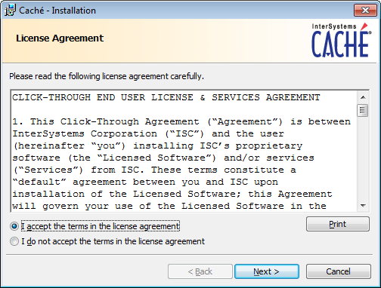

Figure 1

Click **NEXT** at the Define Cache Instance Name.



Figure 2

Click **Next** at Destination Folder

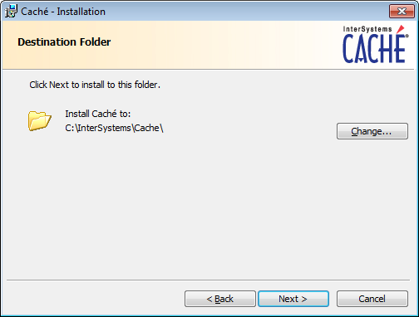

Figure 3

Choose **Development** and click **Next**.

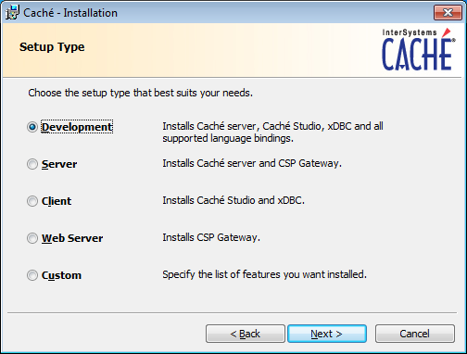

Figure 4

Continue following the instructions and accept the defaults for your system.

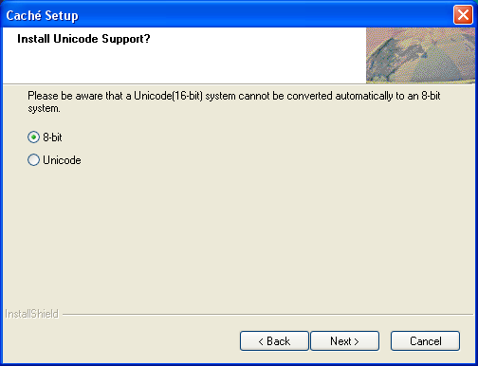

Figure 5

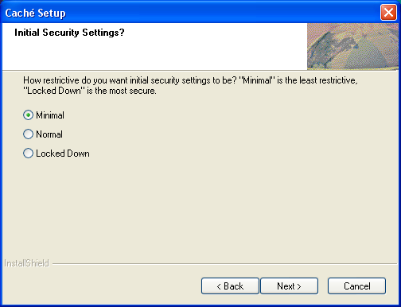

Figure 6

Click **Install**

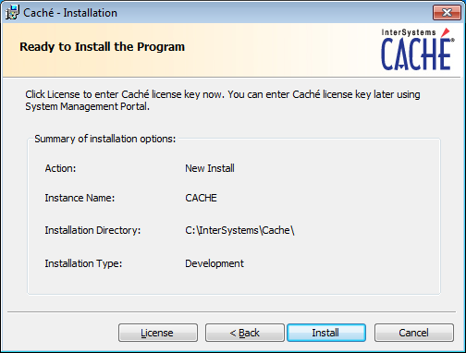

Figure 7

Uncheck **Display the Getting Started page** and click **Finish**.

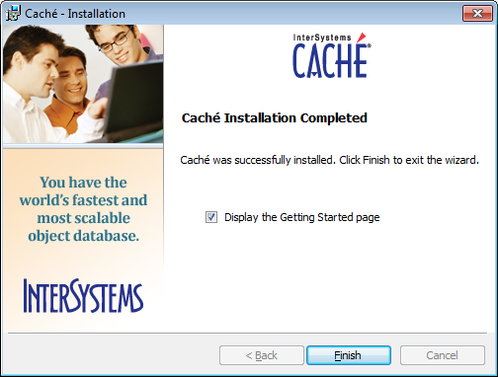

Figure 8

Upon the completion of a successful installation, a "Blue Cube" will appear on the PC toolbar in the lower right hand side of the screen.

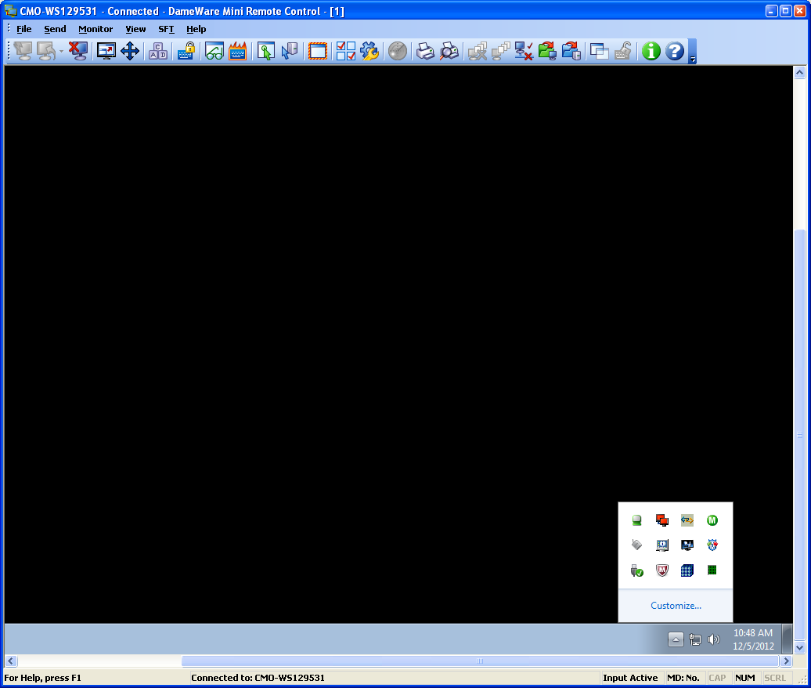

Figure 9

## Caché Configuration Manager

Caché must be configured with databases, namespaces, and routines by using the Management Portal located on the Caché cube menu options.

Right clicking on the cube will display the menu options for Caché, and then choose **Management Portal**.

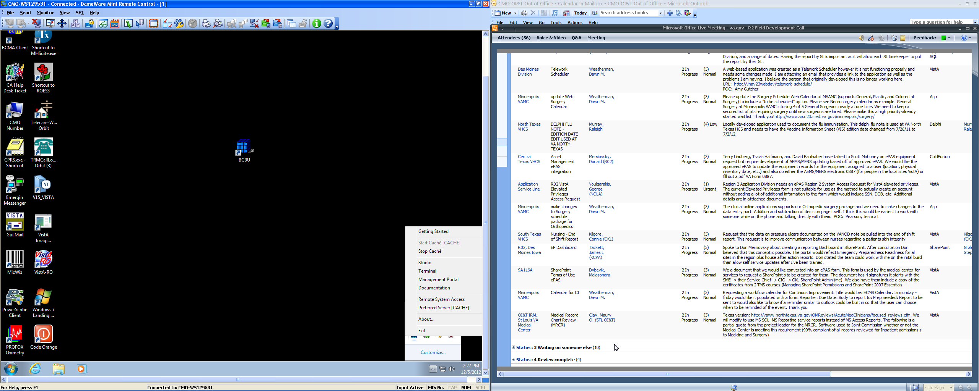

Figure 10

### Adding a Database

The first step is to add a Database. From the Main Screen, choose the **Menu** button and then **Configure Databases**.

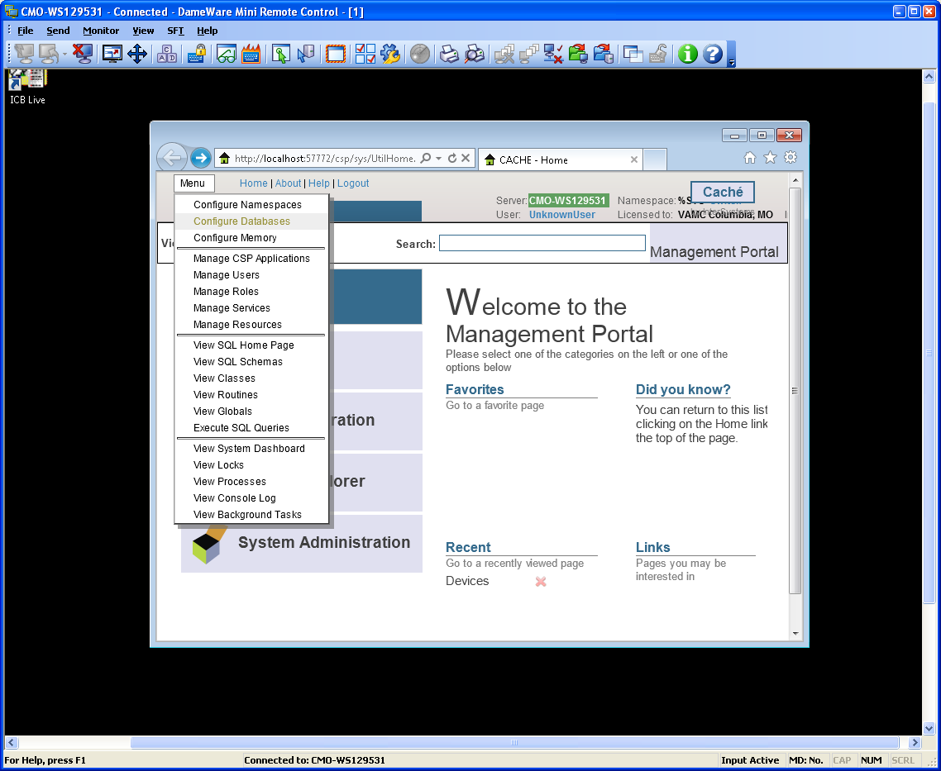

Figure 11

Select the **Local Database** option and then **Create New Database** button.

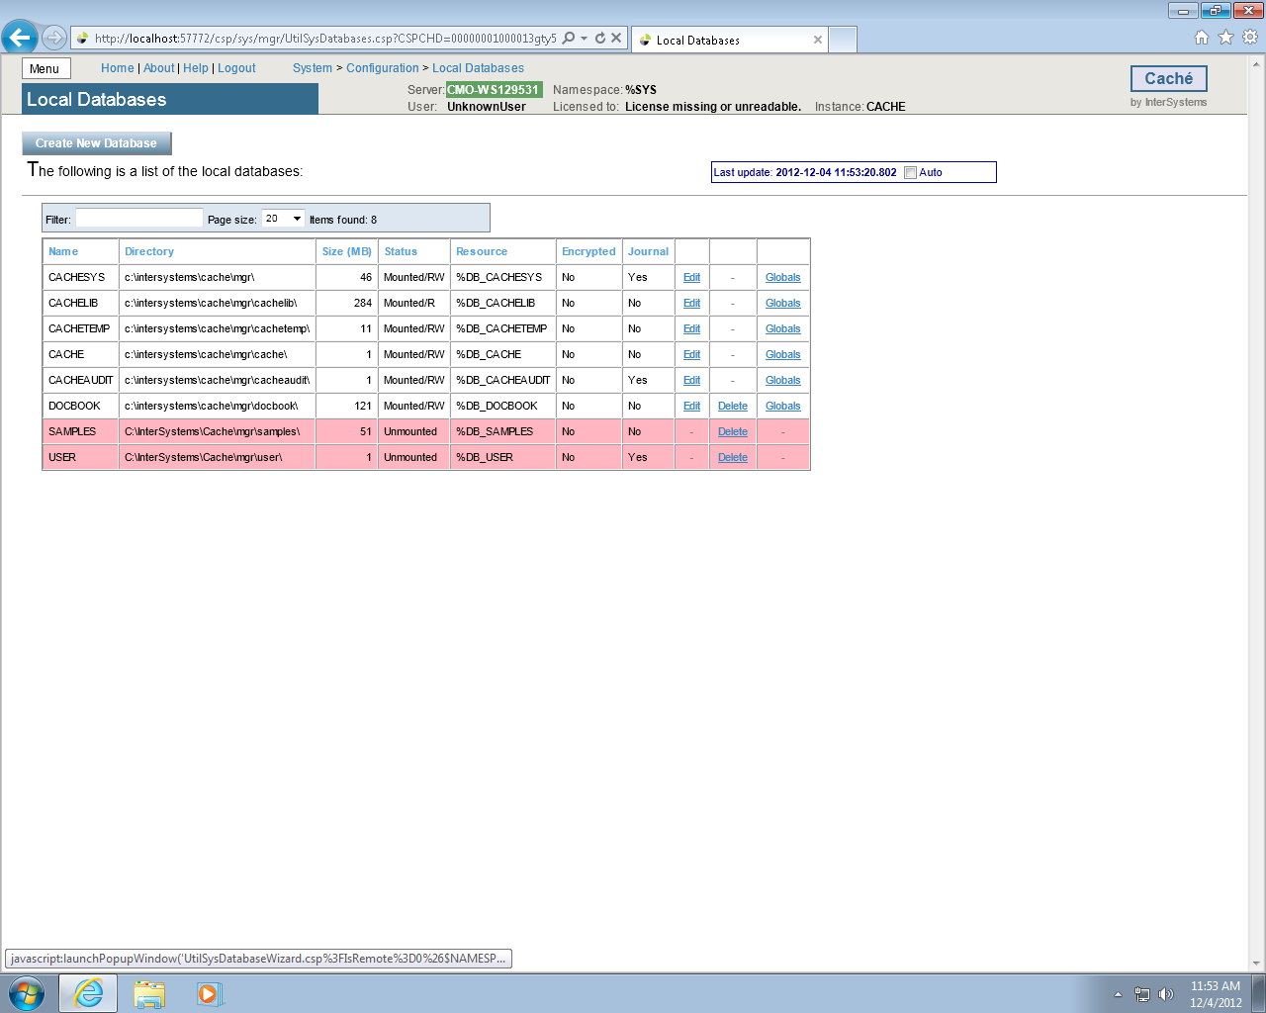

Figure 12

Type **VISTA** as the name of the database and enter **C:\BCMABU** into the Directory Selected field. Click **NEXT** to continue.

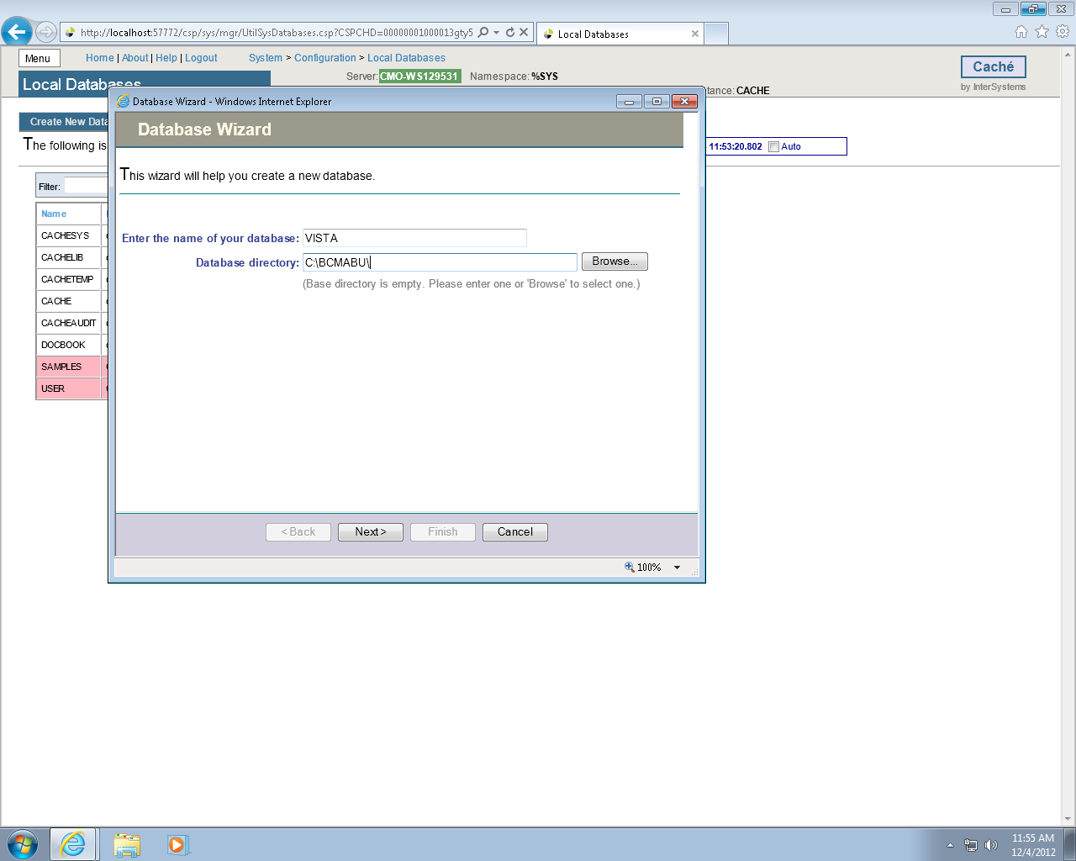

Figure 13

Verify values entered and click **FINISH**.

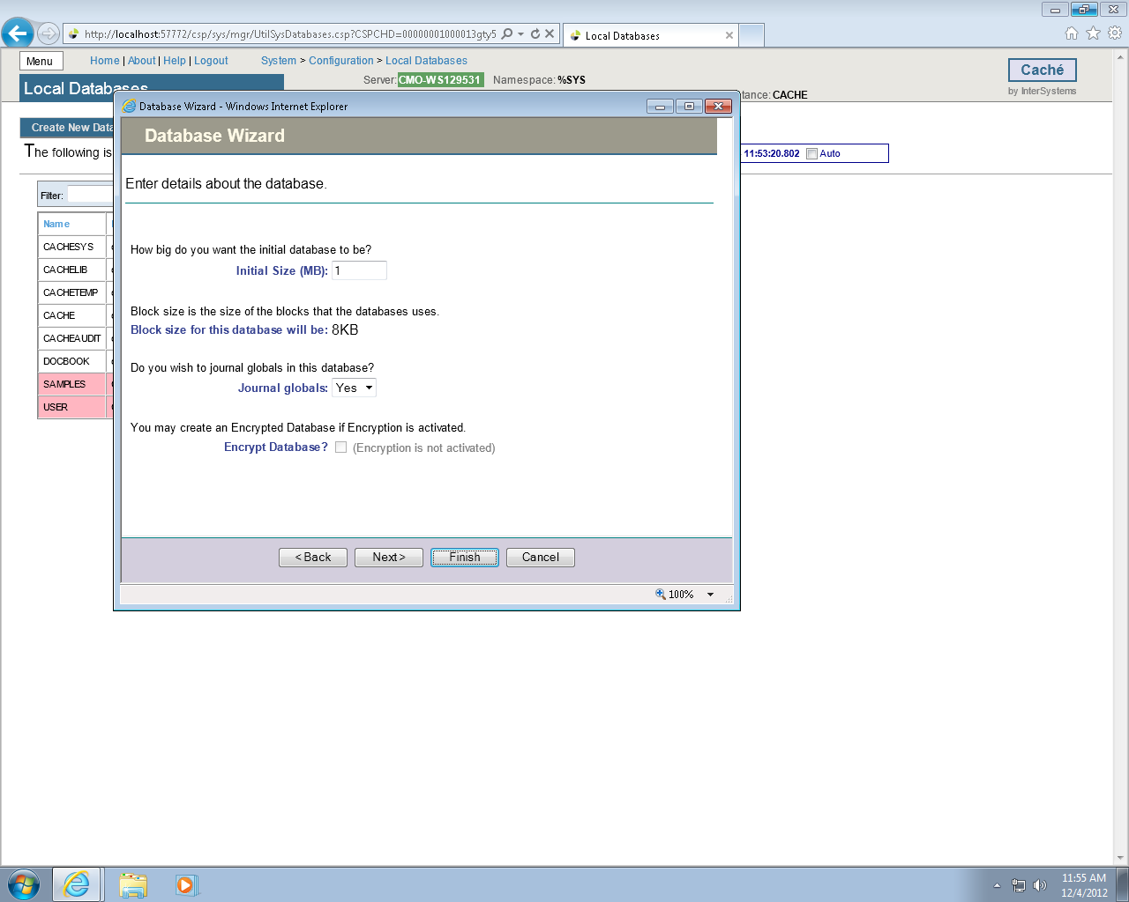

Figure 14

The newly created database should now appear in the list (bottom of the list) with C:\BCMABU\ as its directory.

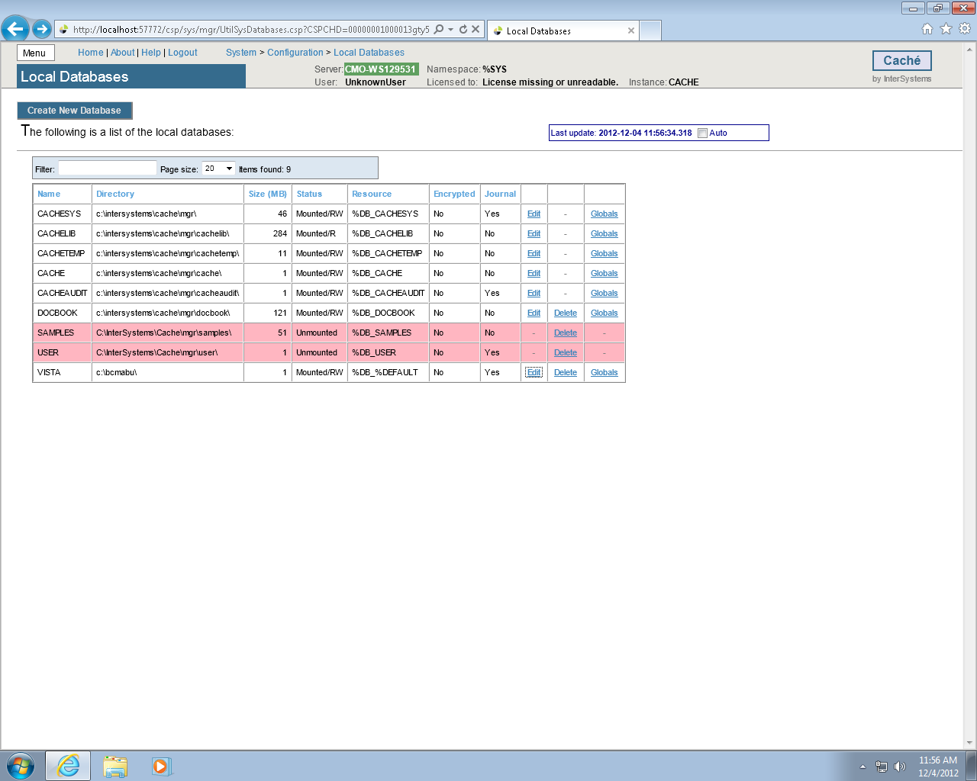

Figure 15

### Adding a Namespace

We will create the namespace VISTA and attach it to the VISTA database.

Click the **MENU** button and choose **Configure Namespaces**.

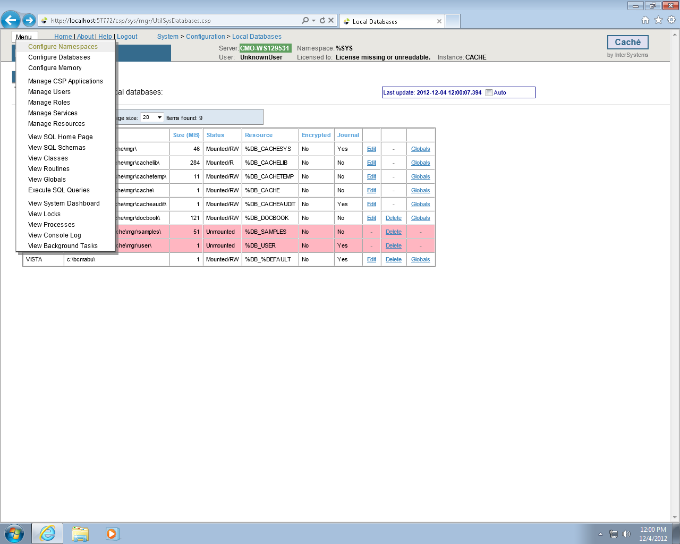

Figure 16

Click Create **New Namespace** button.

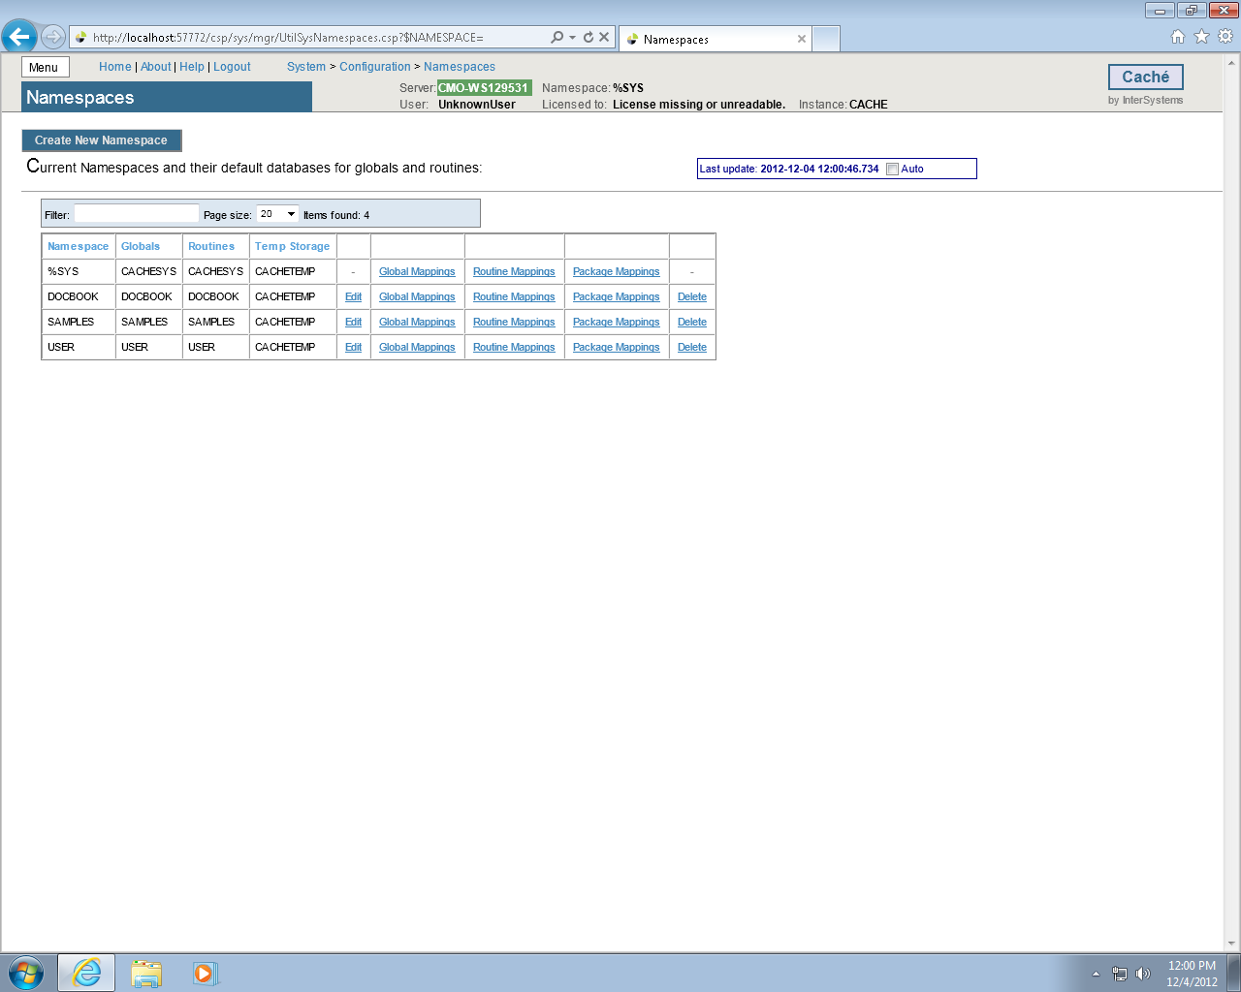

Figure 17

Type **VISTA** as the namespace and select **VISTA – C\BCMABU\** as the existing database. Click **Save**.

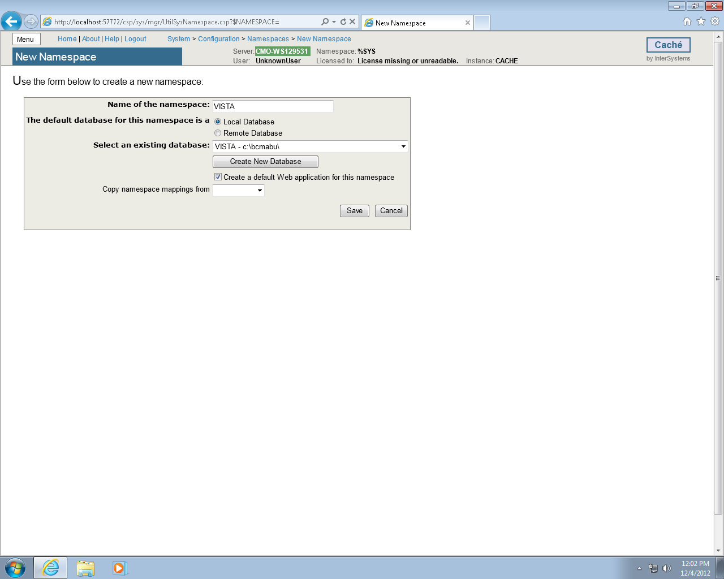

Figure 18

VISTA namespace should be seen in the listing of Caché Namespaces.

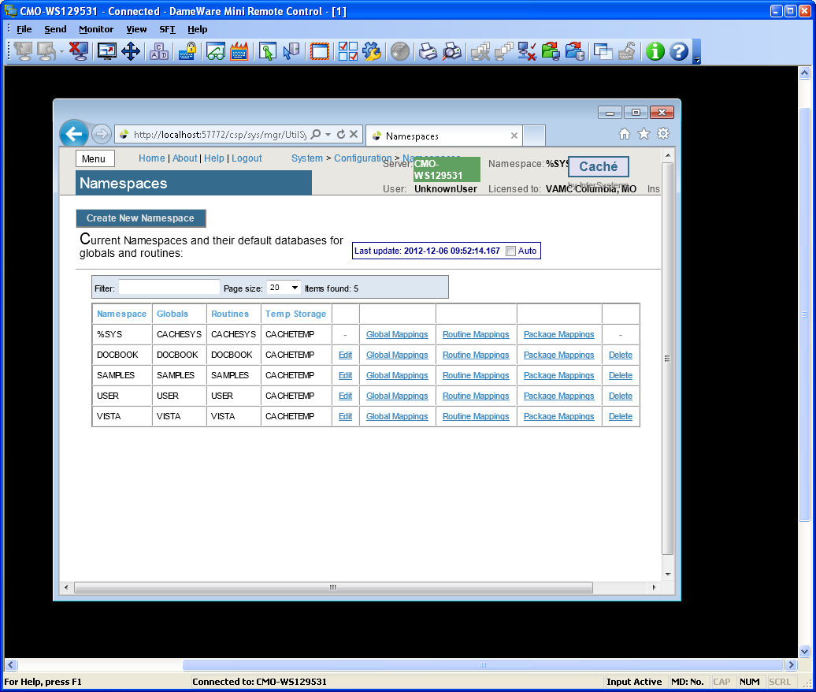

Figure 19

### Global and Routine Mapping

Global and Routine Mappings are created under the Configuration Namespaces option by selecting Global Mappings and Routine Mappings for the VISTA namespace.

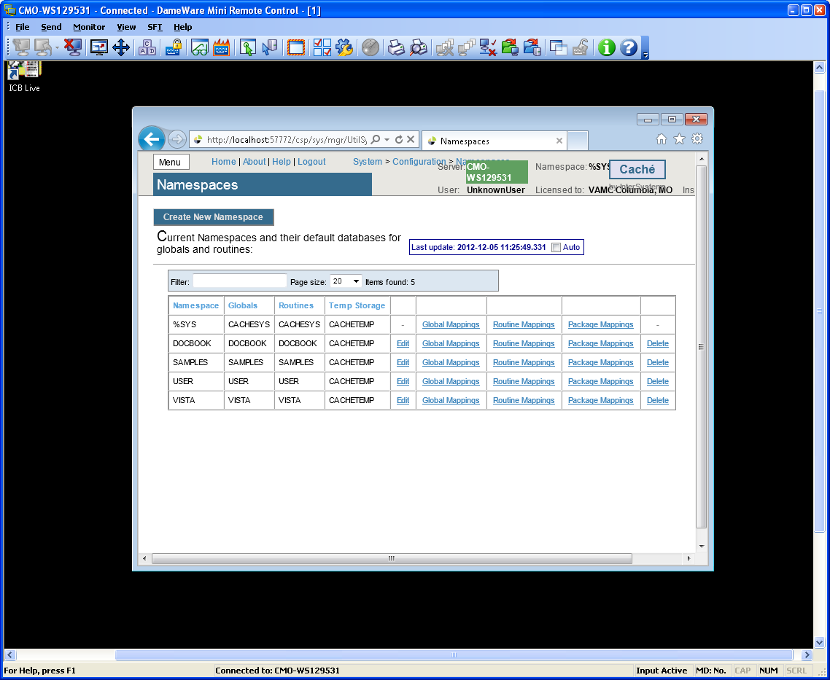

Figure 20

### Global Mapping

Click Global Mappings for the **VISTA** namespace. Then click **New Global Mapping** to create the global mapping definition as shown in the following slide.

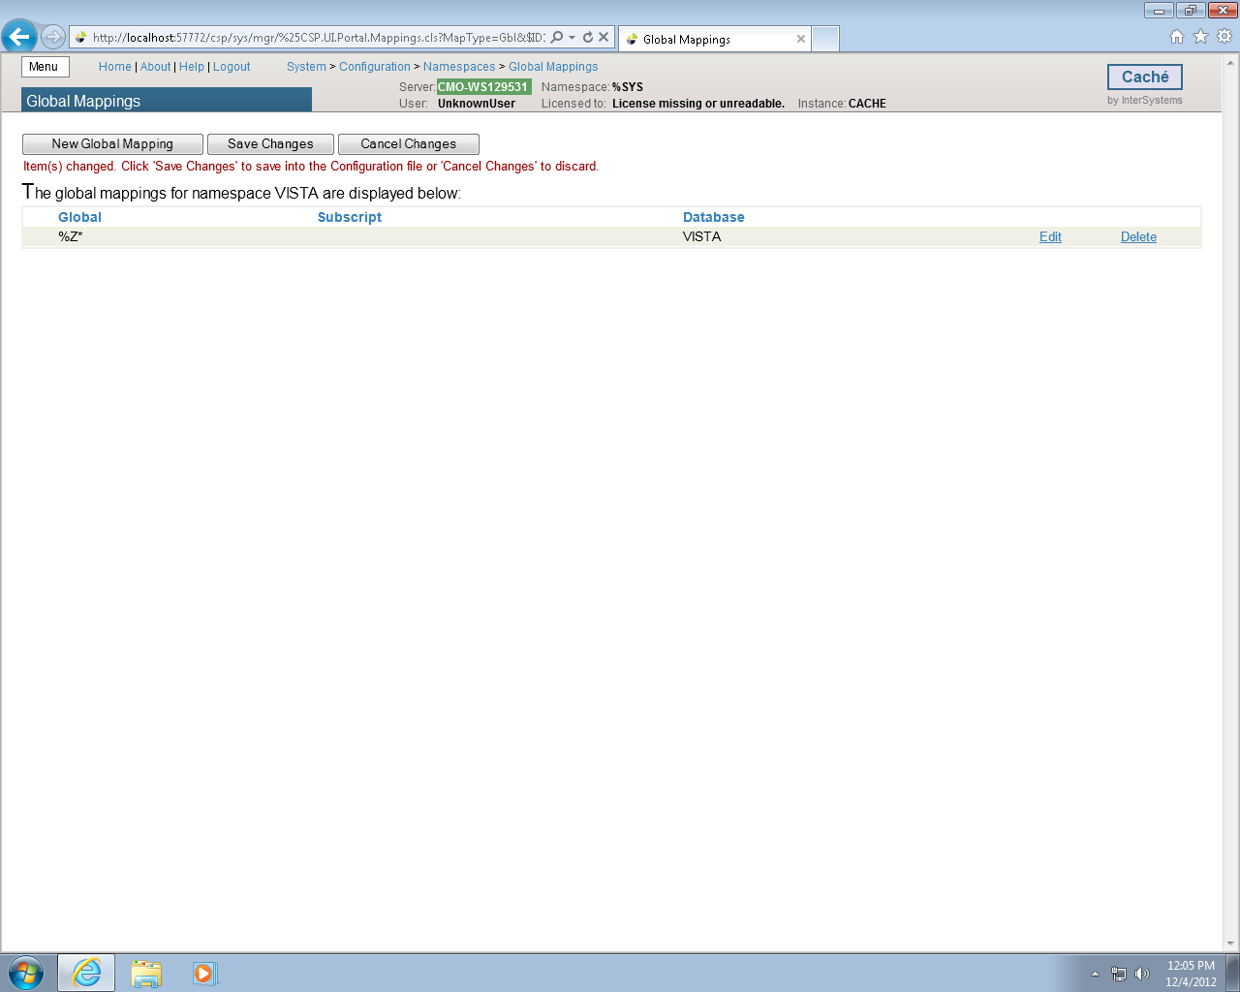

Figure 21

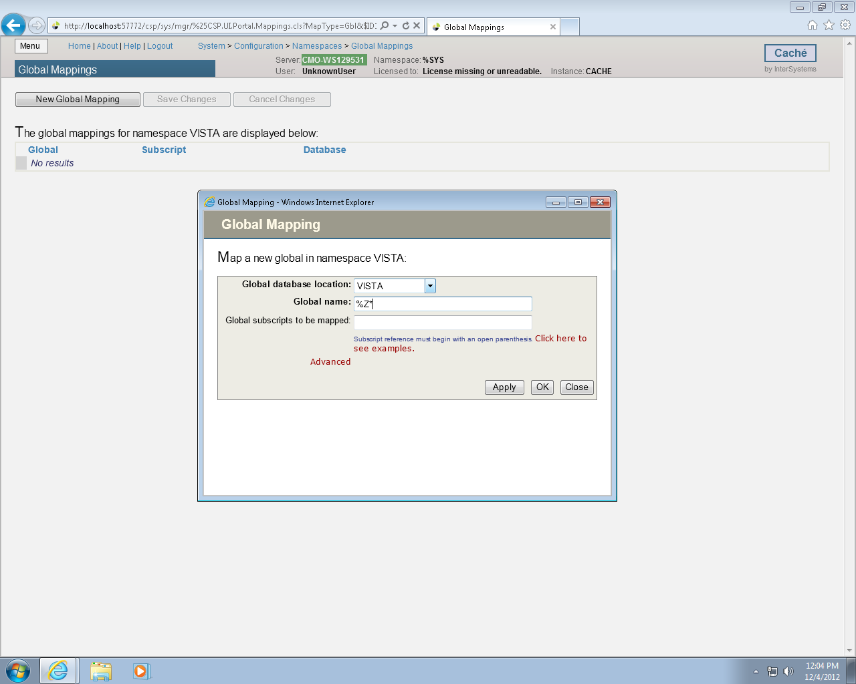

Figure 22

### Routine Mapping

Click the **Menu** button (Figure 22) and then **Configure Namespaces**.

The Global Database Location is **VISTA** and the Global name is **%Z*.** Click **Apply** (Figure 21)and **Save Changes**.

Select Routine Mapping.

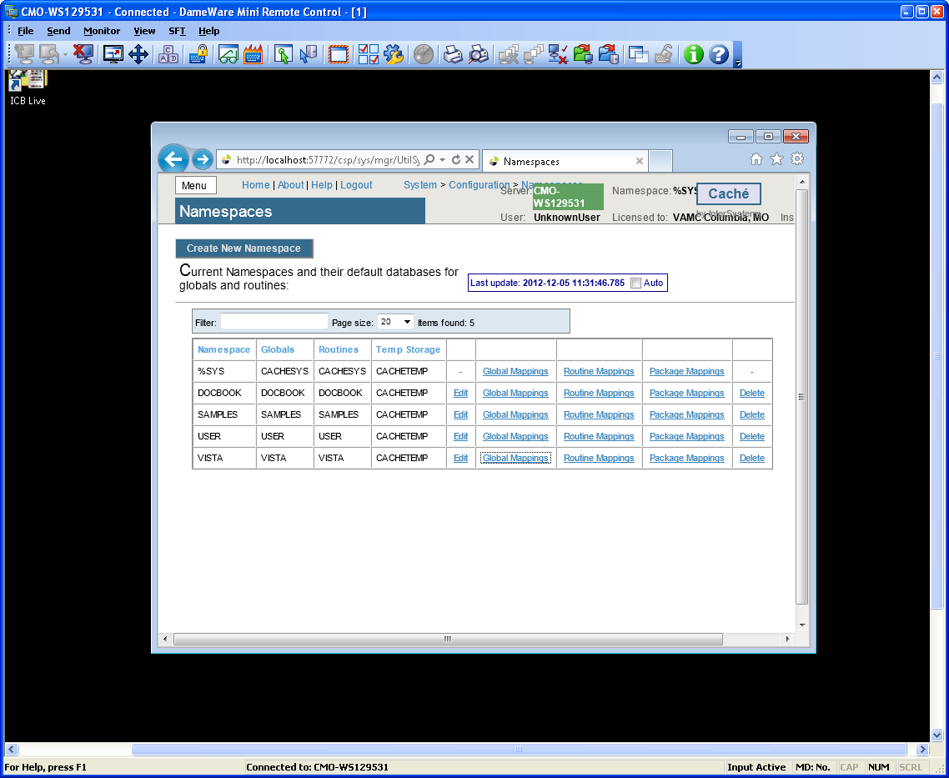

Figure 23

Select **New Routine Mapping**. Type the first routine name, **%DT*,** (Figure 24) in the space provided and select **VISTA** as the routine database location. Click **Apply**. Repeat this procedure for routine names %**RCR, %XU* and %Z*.** When complete, your routine mapping should appear as shown in Figure 25. Click **Save Changes** and close this window.

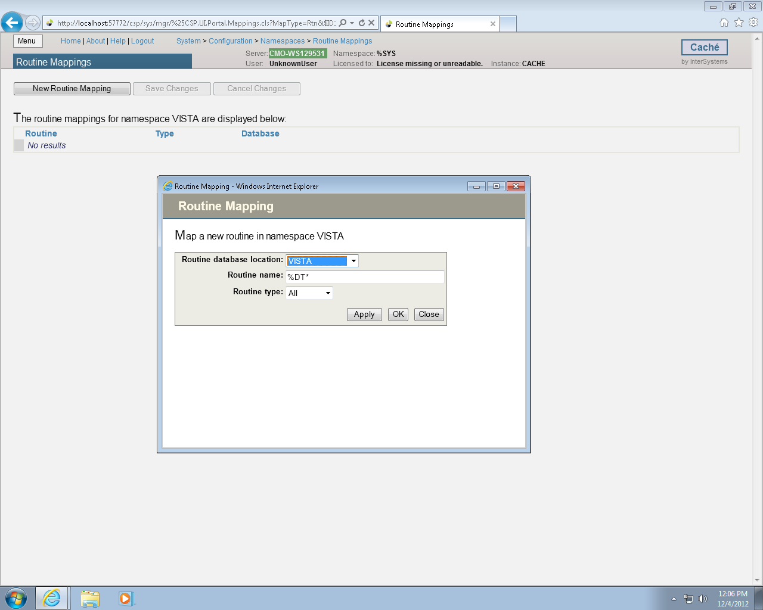

Figure 24

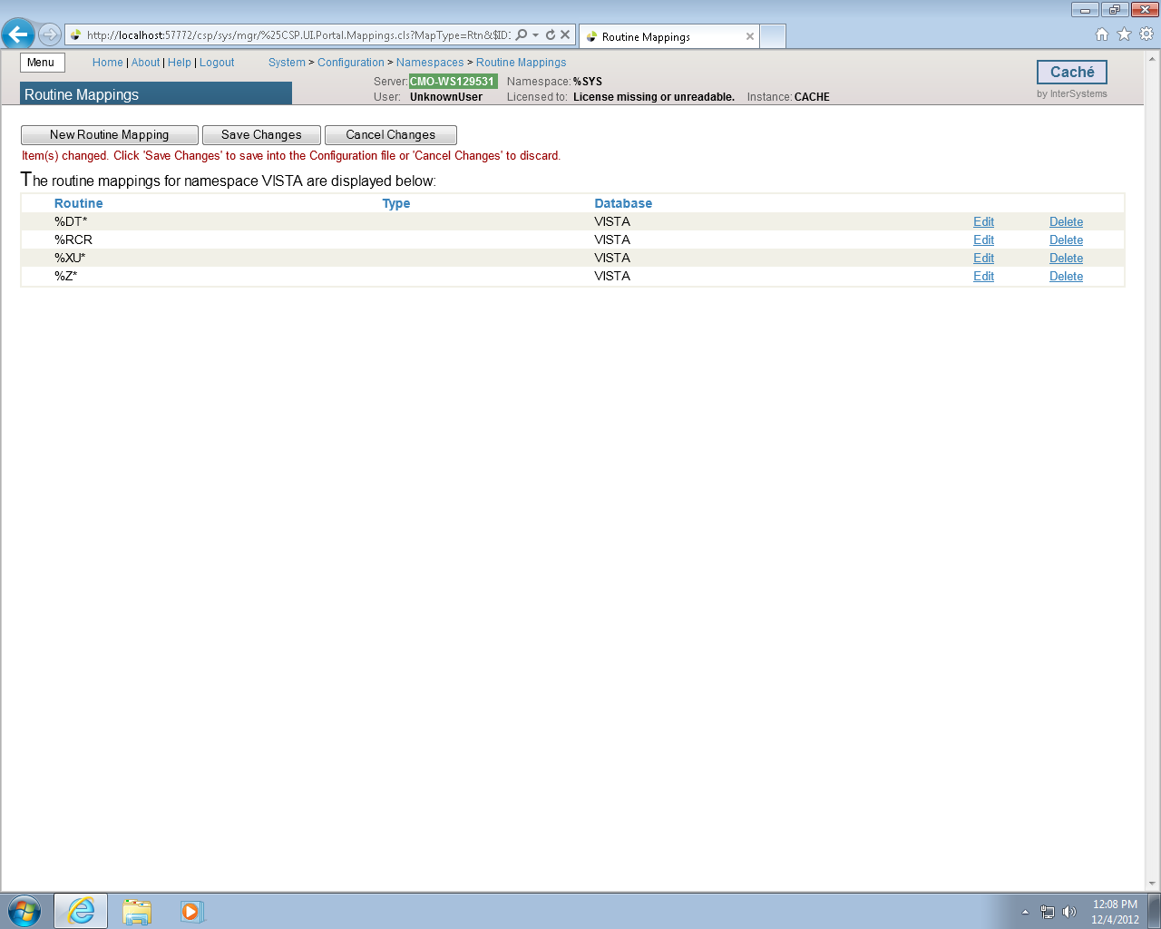

Figure 25

Shut down CACHÉ

Click the Blue Cube (PC toolbar in the lower right hand side of the screen) and choose Stop Cache.

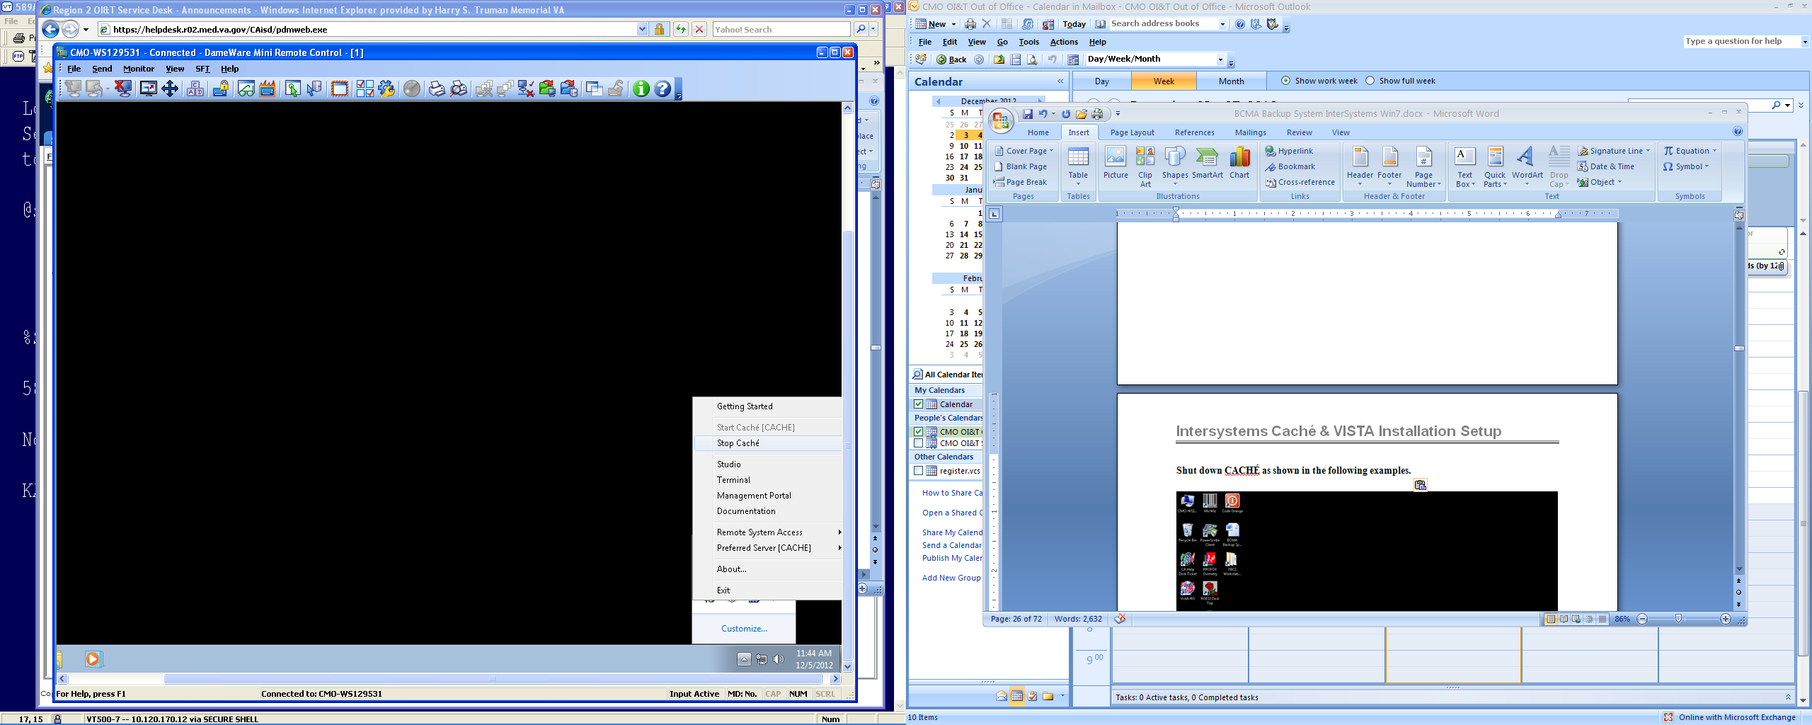

Figure 26

You will see the following screen as CACHE shuts down.

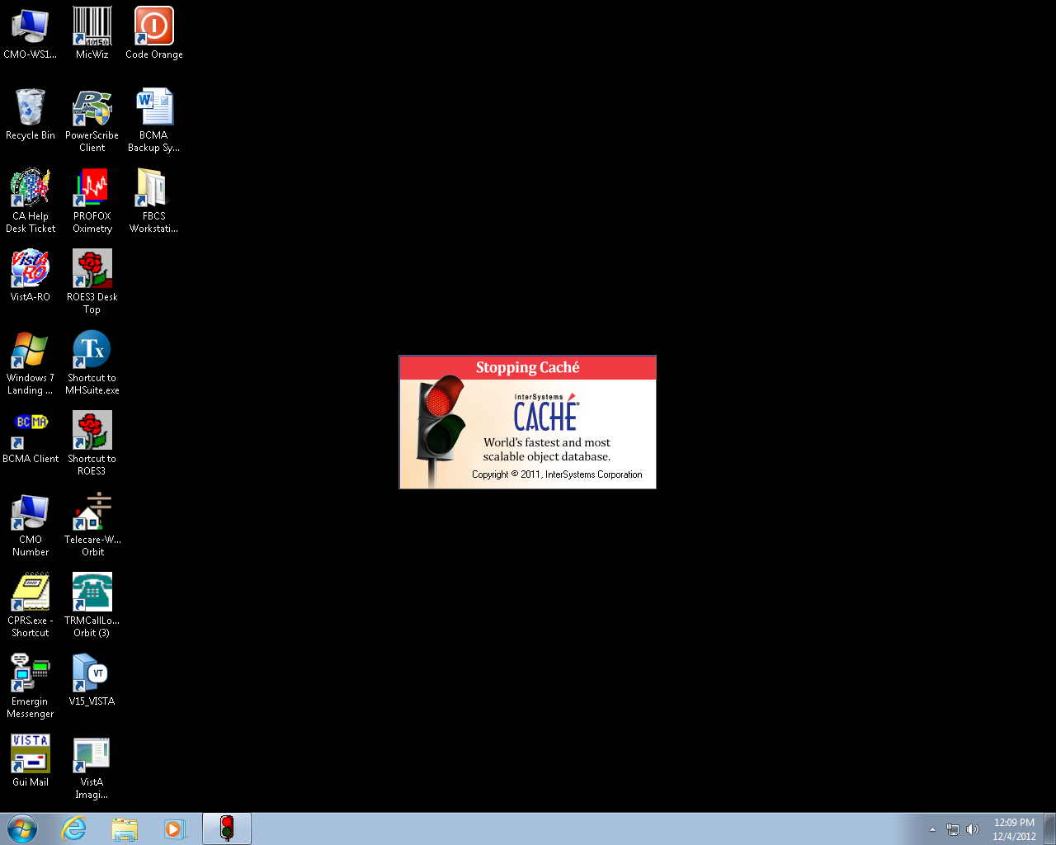

Figure 27

### Cache Licenses install

The license information is a text file sent to you by InterSystems (cache.key).

Copy and paste into the **C:\InterSystems\Cache\mgr** folder.

CACHE.DAT

Copy the **CACHÉ.DAT** file you downloaded from the VA FTP site and copy it to the **C:\BCMABU** folder.

You may receive a message stating the file is already present and do you want to replace it with the file you are importing. If so, answer **YES**.

### Removing Read/Archive Properties

Using the "Windows Explorer", remove the Read and Archive Properties from the CACHÉ.DAT file. Right click “CACHÉ.DAT” and select "Properties" under the General Tab and Click Advance to remove Archive. Click Apply and then OK.

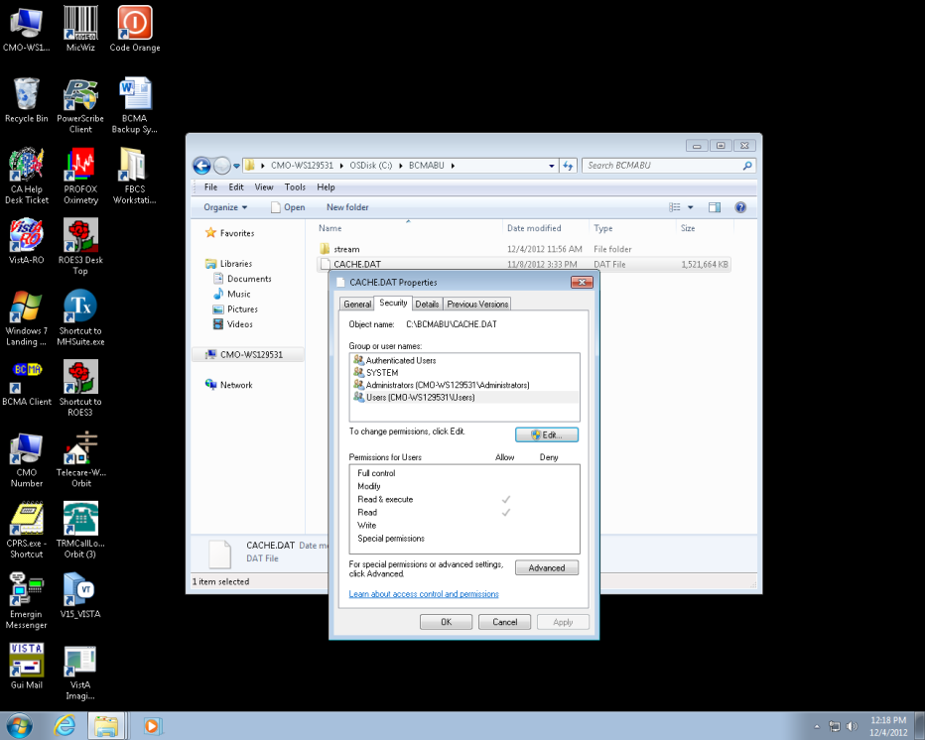

Figure 28

## Telnet Instructions

Start Caché. Note: The Cache Cube icon is Gray in color at this point, not Blue.

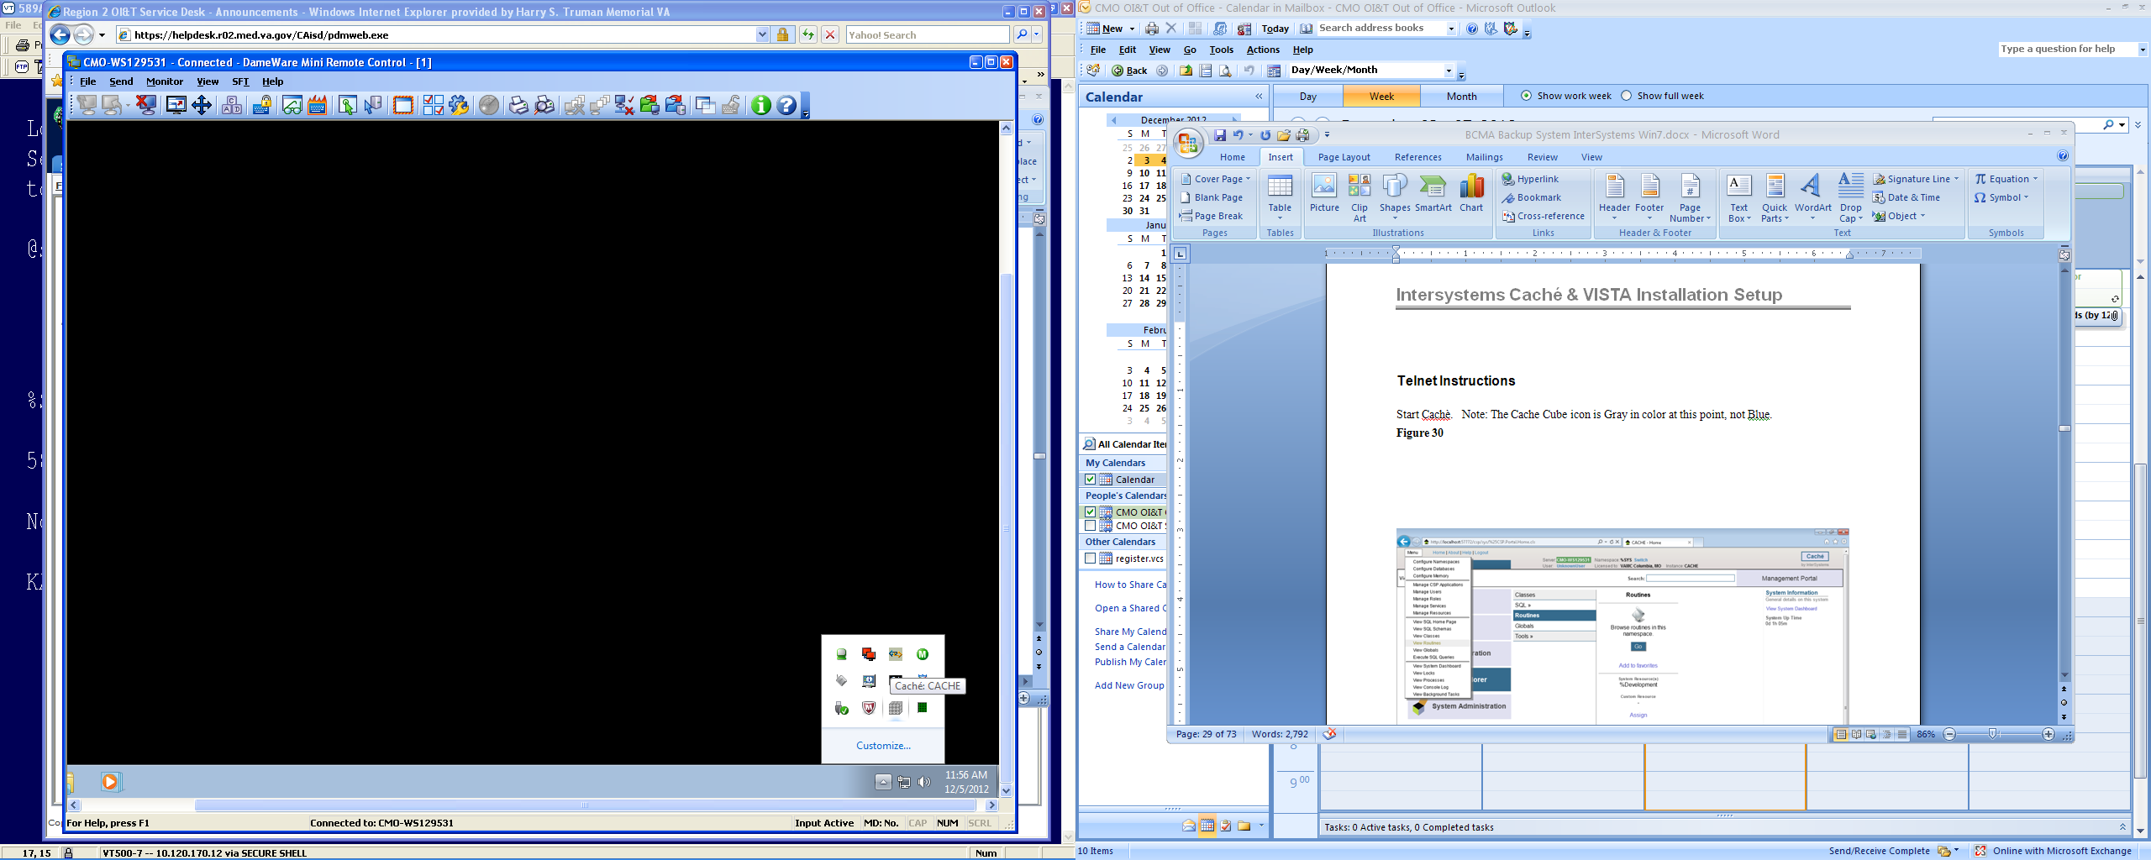

Figure 29

What we are going to do next is to move the **ZSTU** routine from the **VISTA** namespace to the **%SYS** namespace using the Management Portal.

Select Menu **button** then **View Routines.**

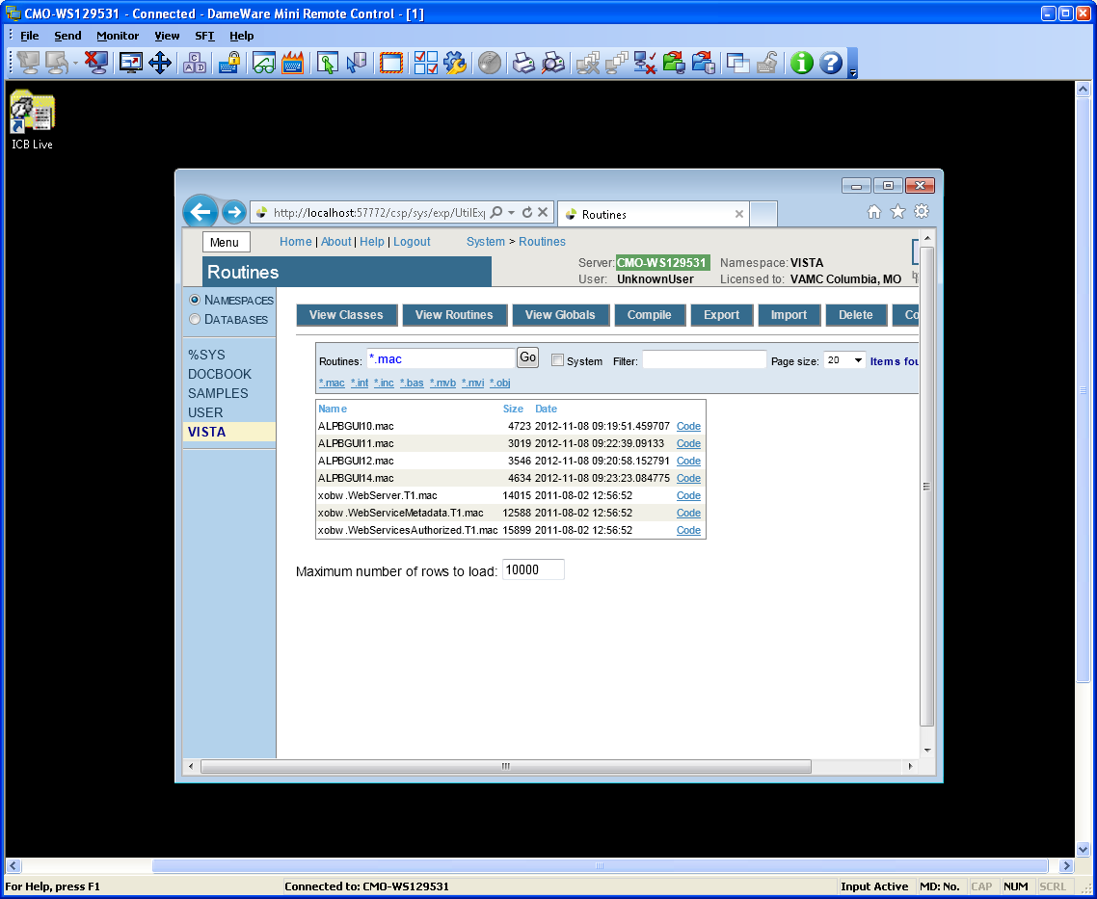

Figure 30

Select VISTA on left side of the screen.

Enter ZSTUin the Routines box and click **Export.**

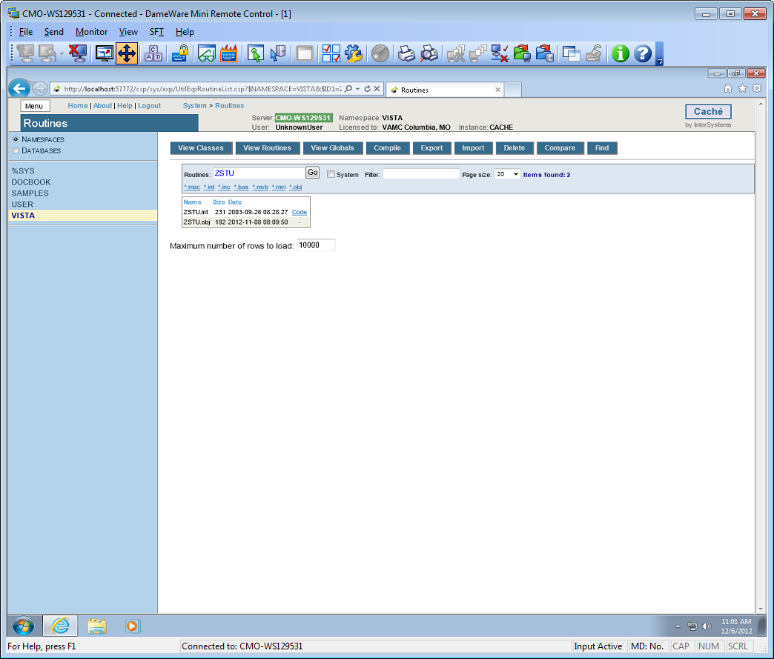

Figure 31

Make sure the check box is selected for the routine (ZSTU.int).

Click **Export**

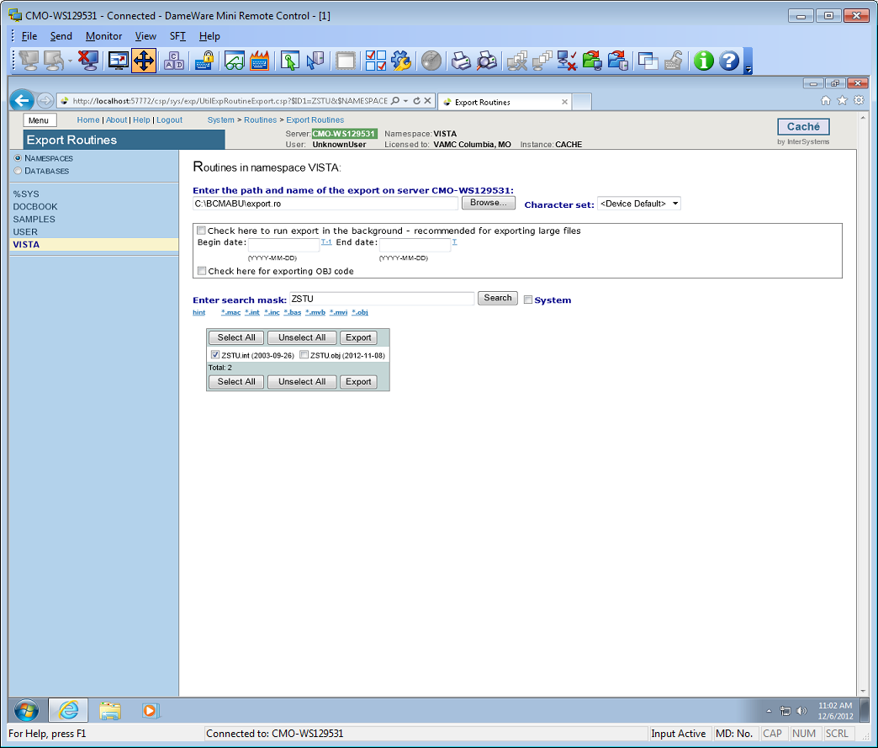

Figure 32

When finished, a message stating it was completed should appear.

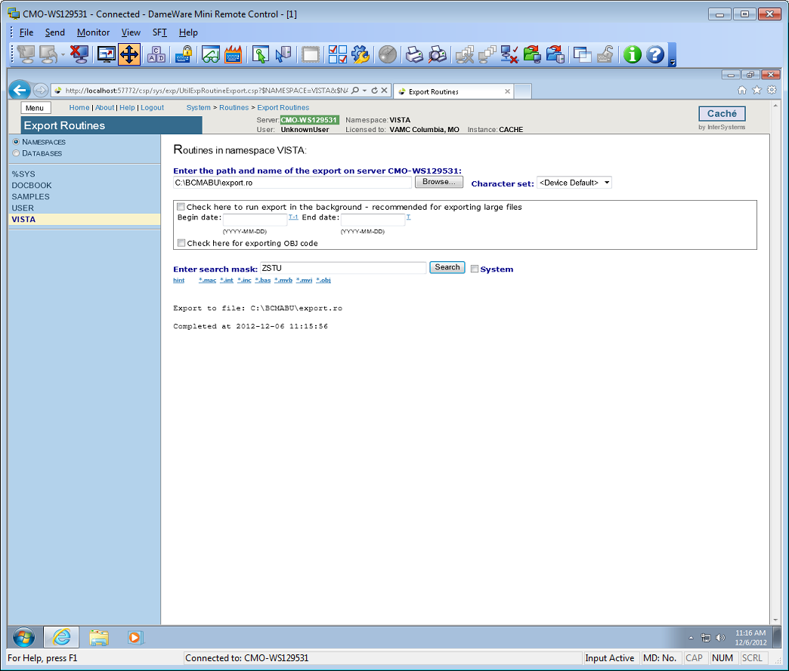

Figure 33

Click the **Menu button** and then **View Routines**. See steps 1 -6 to accomplish the following: Select the **%SYS** namespace (left side of screen). Select **Import** from across the top. Select the **%SYS** namespace (left side of screen). Browse to the path where you exported the routine. Select the routine and click **OK**.

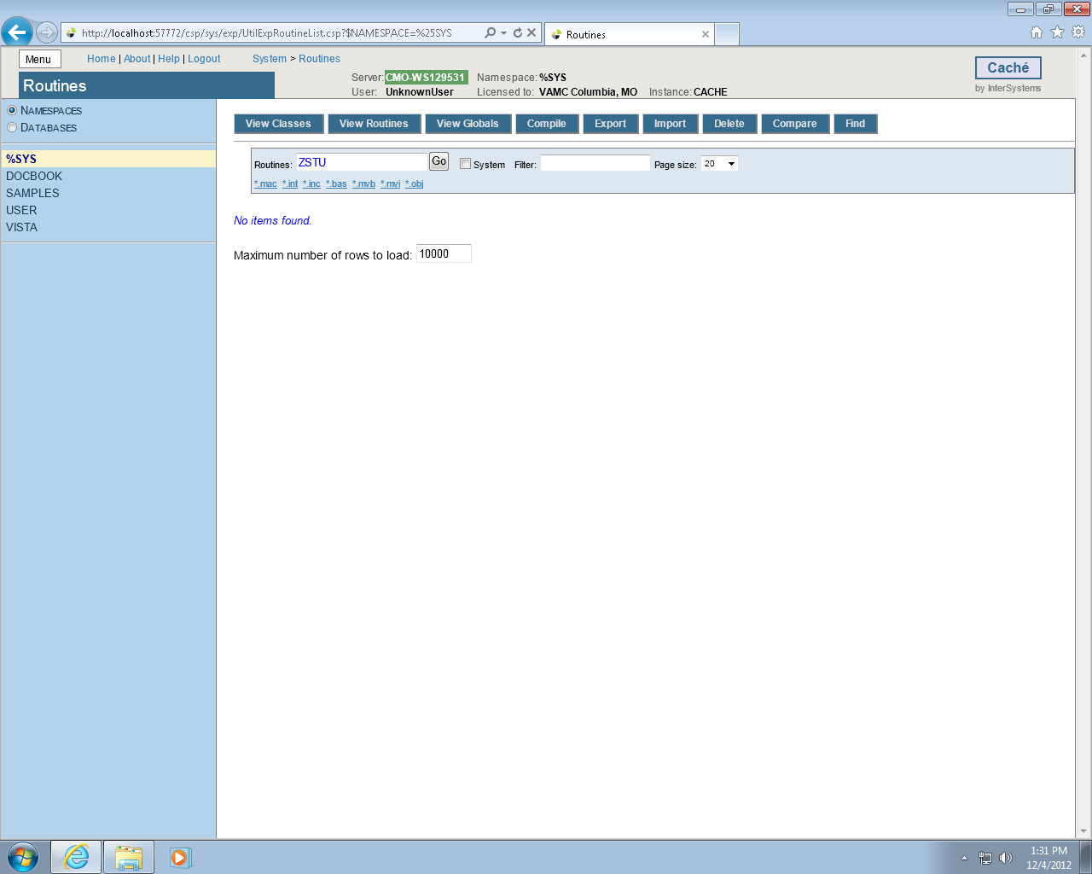

Figure 34

*Step 1.*

Select **%SYS** on left side of the screen, click the **Browse Button**

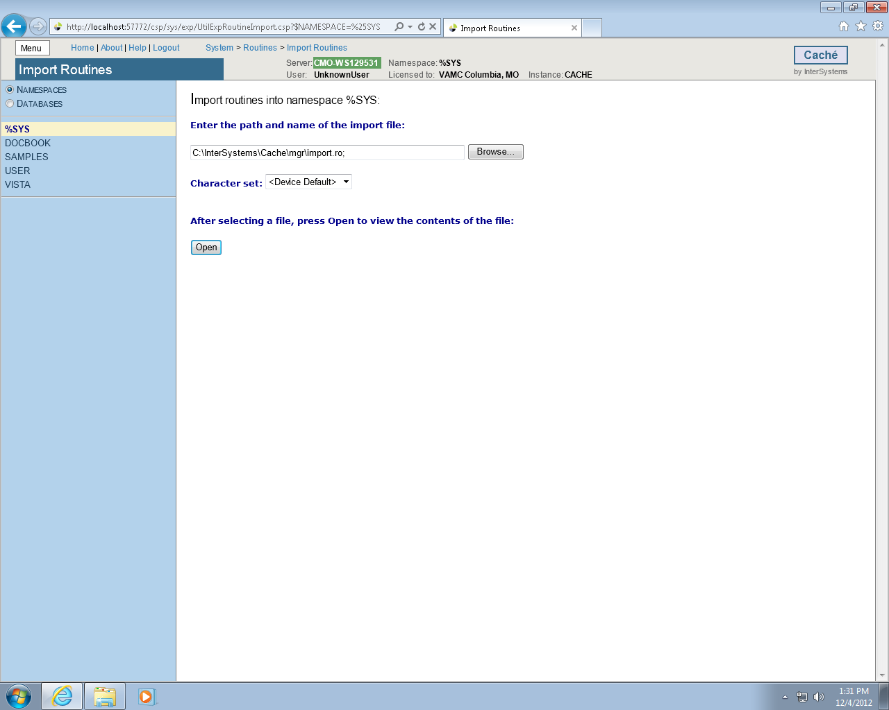

Figure 35

*Step 2.*

Select **C:\**

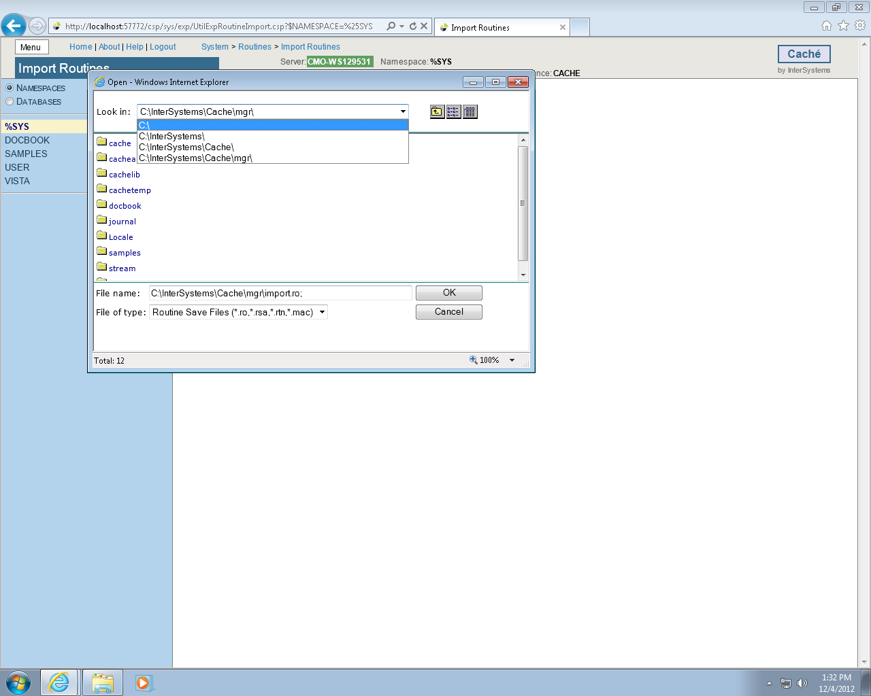

Figure 36

*Step 3*.

Click **BCMABU**

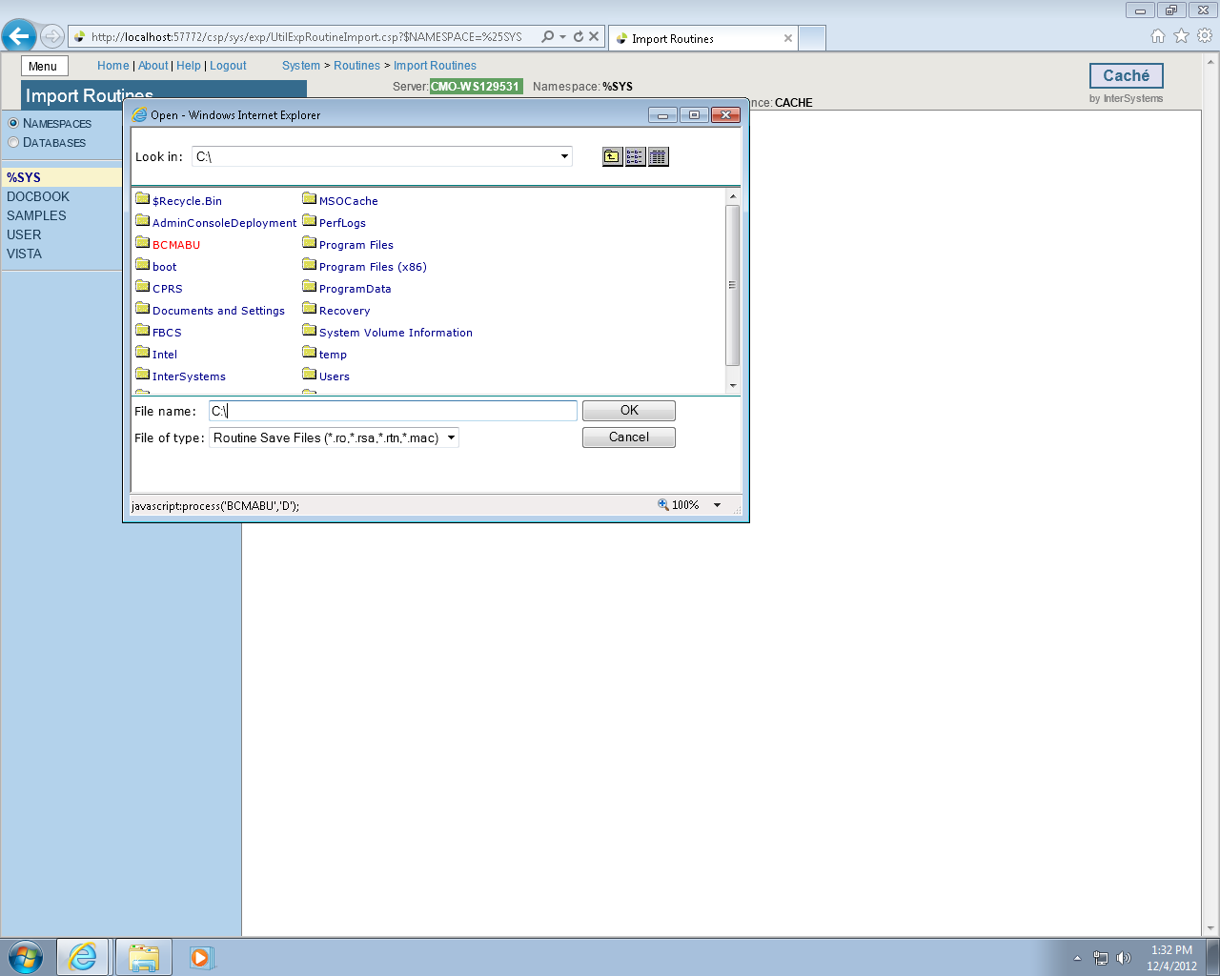

Figure 37

*Step 4*.

Click **export.ro** and then the **OK** button.

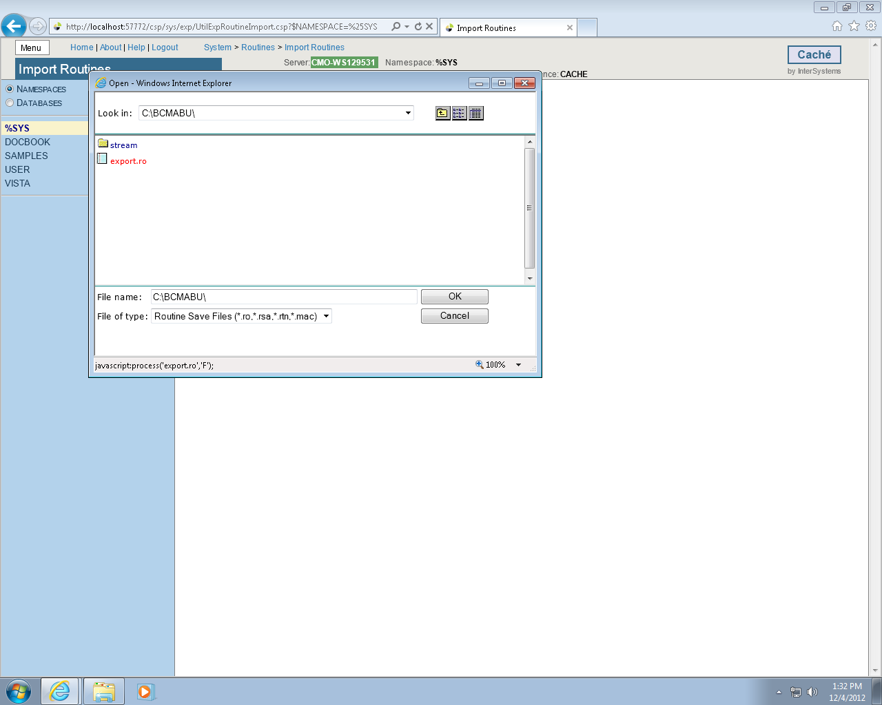

Figure 38

*Step 5*.

Click the **OPEN** button.

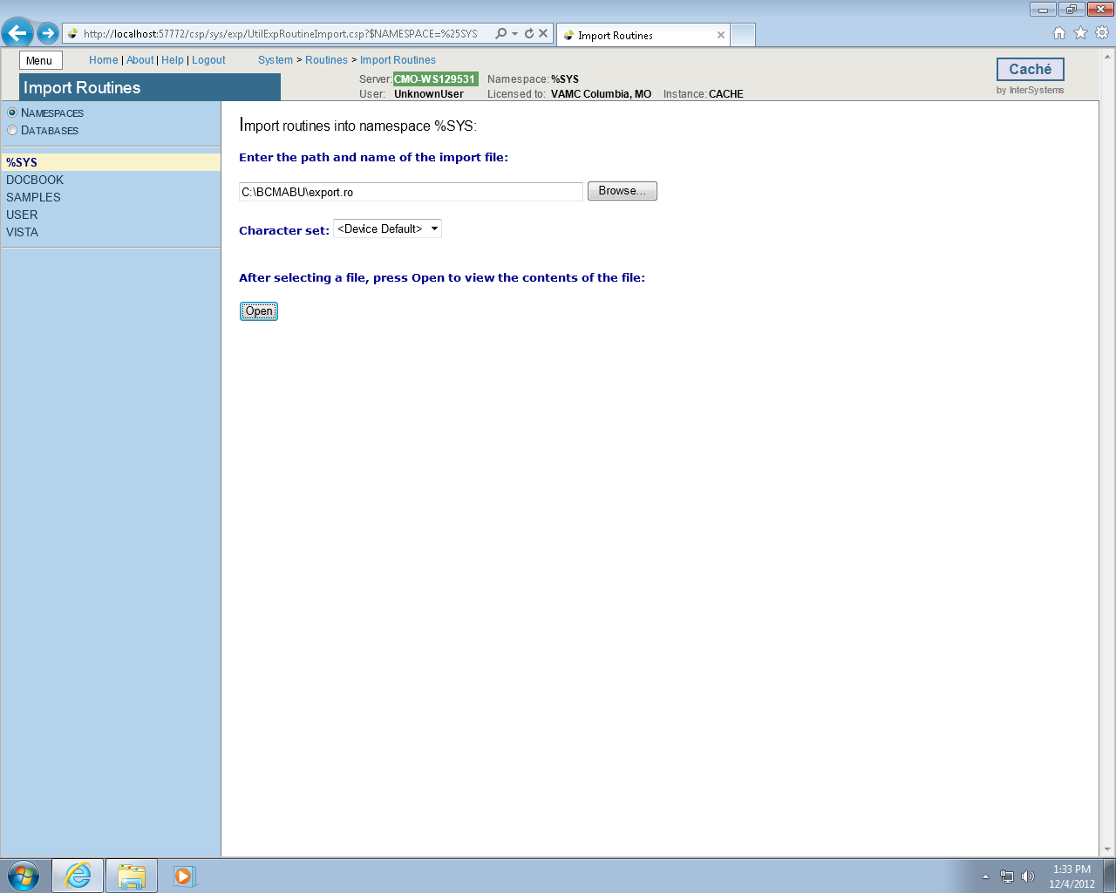

Figure 39

*Step 6*.

Make sure the box is checked by ZSTU.INT. Click **Import**. The successful completion message should appear as shown in the following screen.

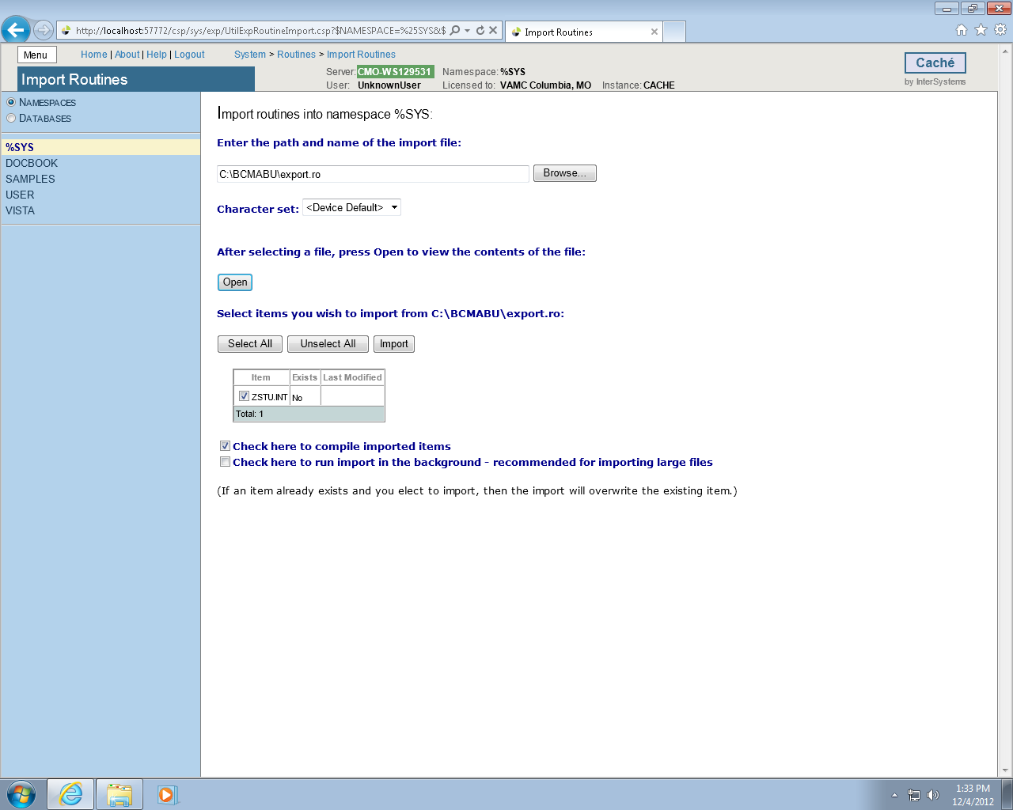

Figure 40

The successful completion message should appear as shown in the following screen.

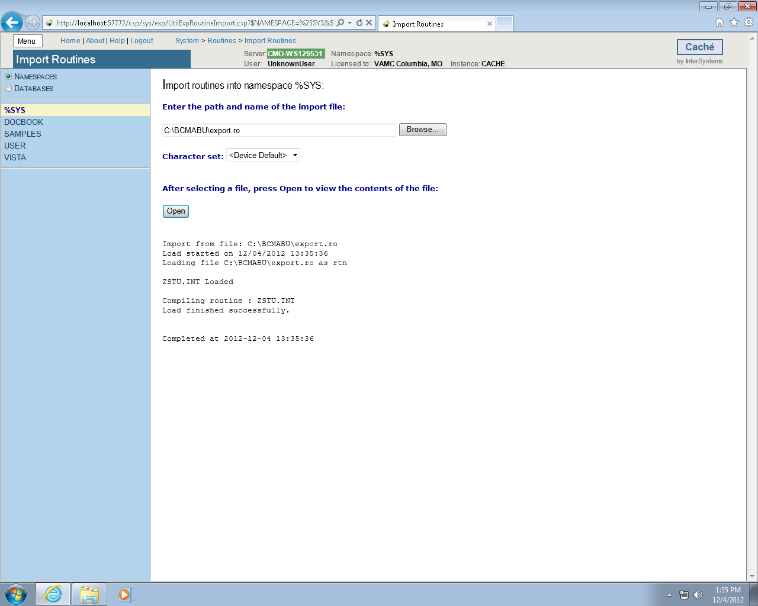

Figure 41

## Setting up Telnet and Terminal Users

We will be using the Management Portal to set up the Unknown User so the Telnet and Terminal Users will connect to the VISTA namespace using the routine ZU.

Click **HOME**

From **the Menu button** select **Manage Users**. The User Accounts will be displayed.

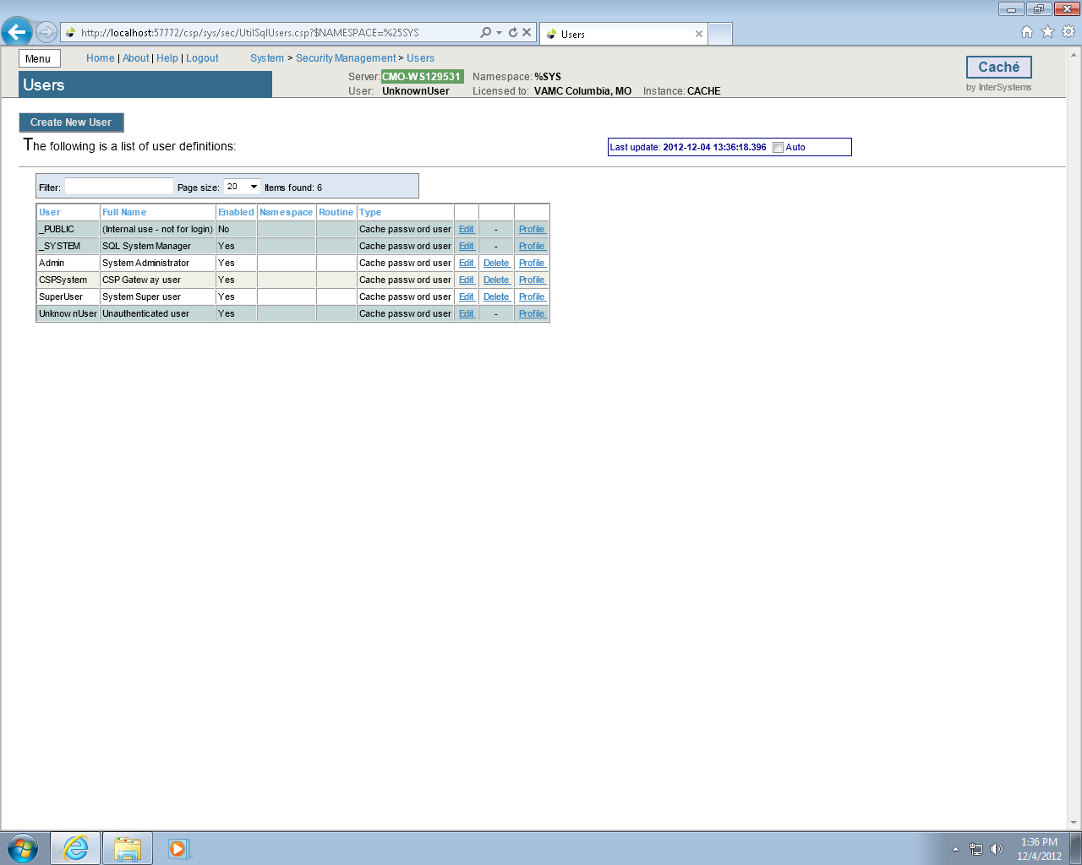

Figure 42

Click **Edit** for the Unknown User. Select **VISTA** as the Startup Namespace and enter **^ZU** as the Startup Tag^Routine. Click **Save** then **Close this window.**

(Note: For programmer access, %PMODE in Default Tag^Routine.)

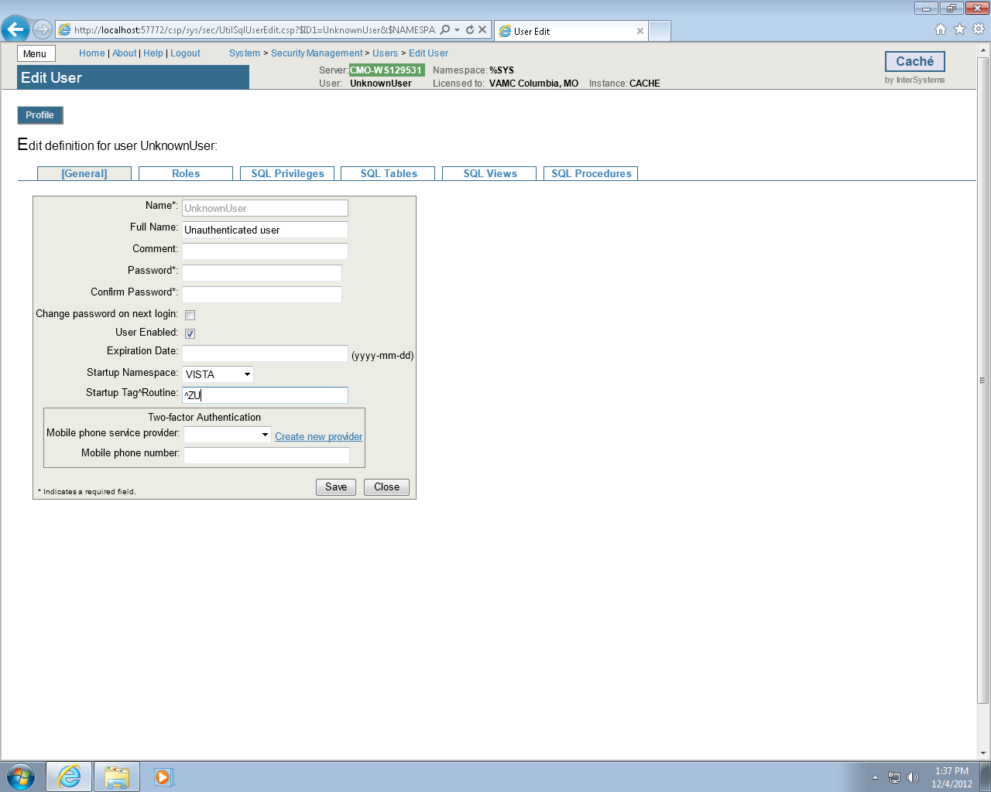

Figure 43

After the edits are done the screen should look like this.

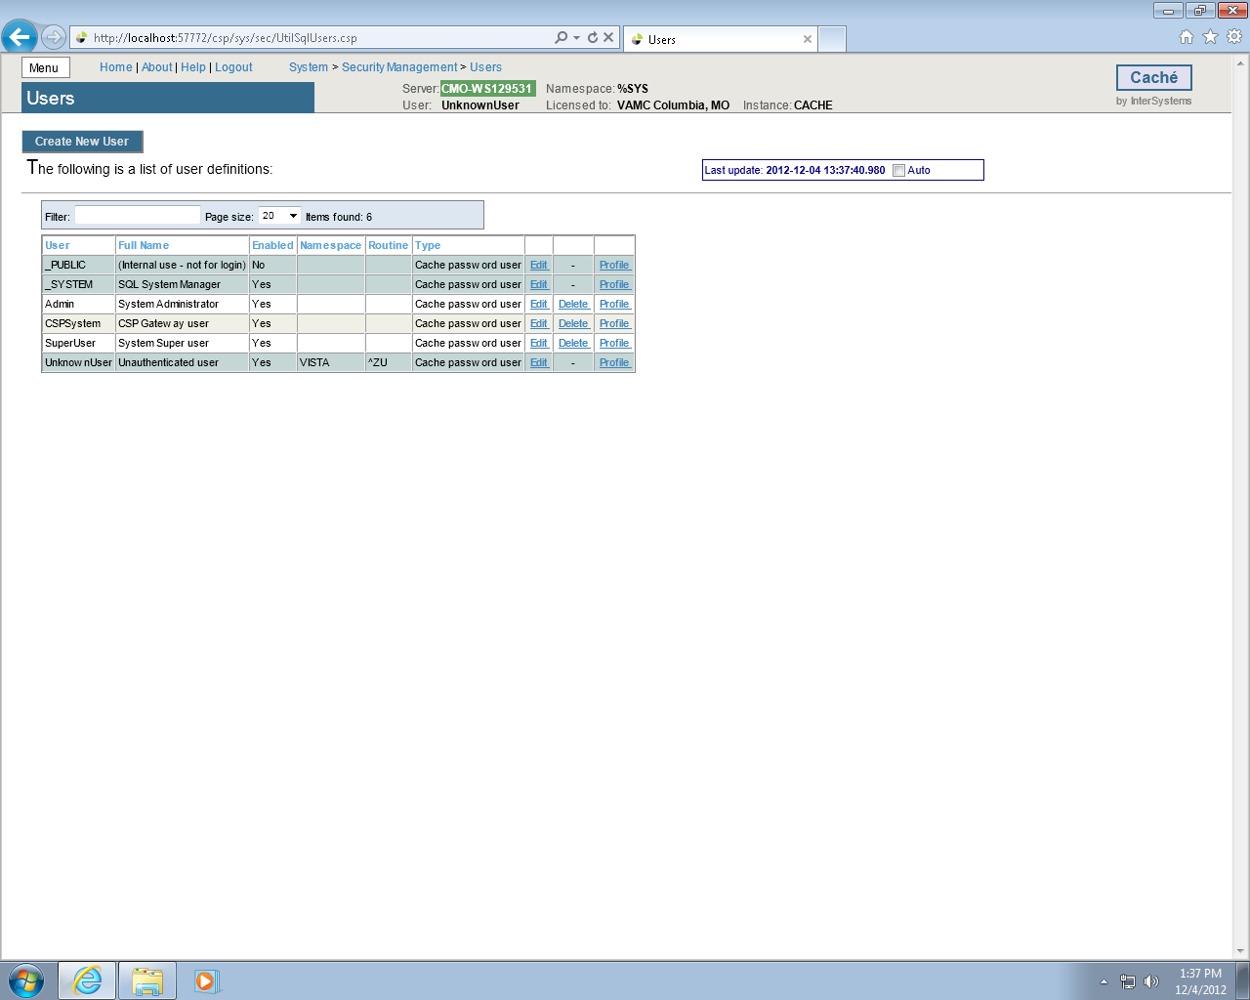

Figure 44

**IMPORTANT NOTE**: Stop and restart Caché. This will be the BCMA Backup Application. The start-up routine **ZSTU** will automatically start up TaskManager.

Verify certain parameters are set for proper operation.

From the Management Portal

Choose Menu, and then Manage Services. Click **%Service Telnet (**Figure 46**)** and set **%Service Telnet Enabled = Yes and Public = Yes**.   
If not, click item and change the settings.

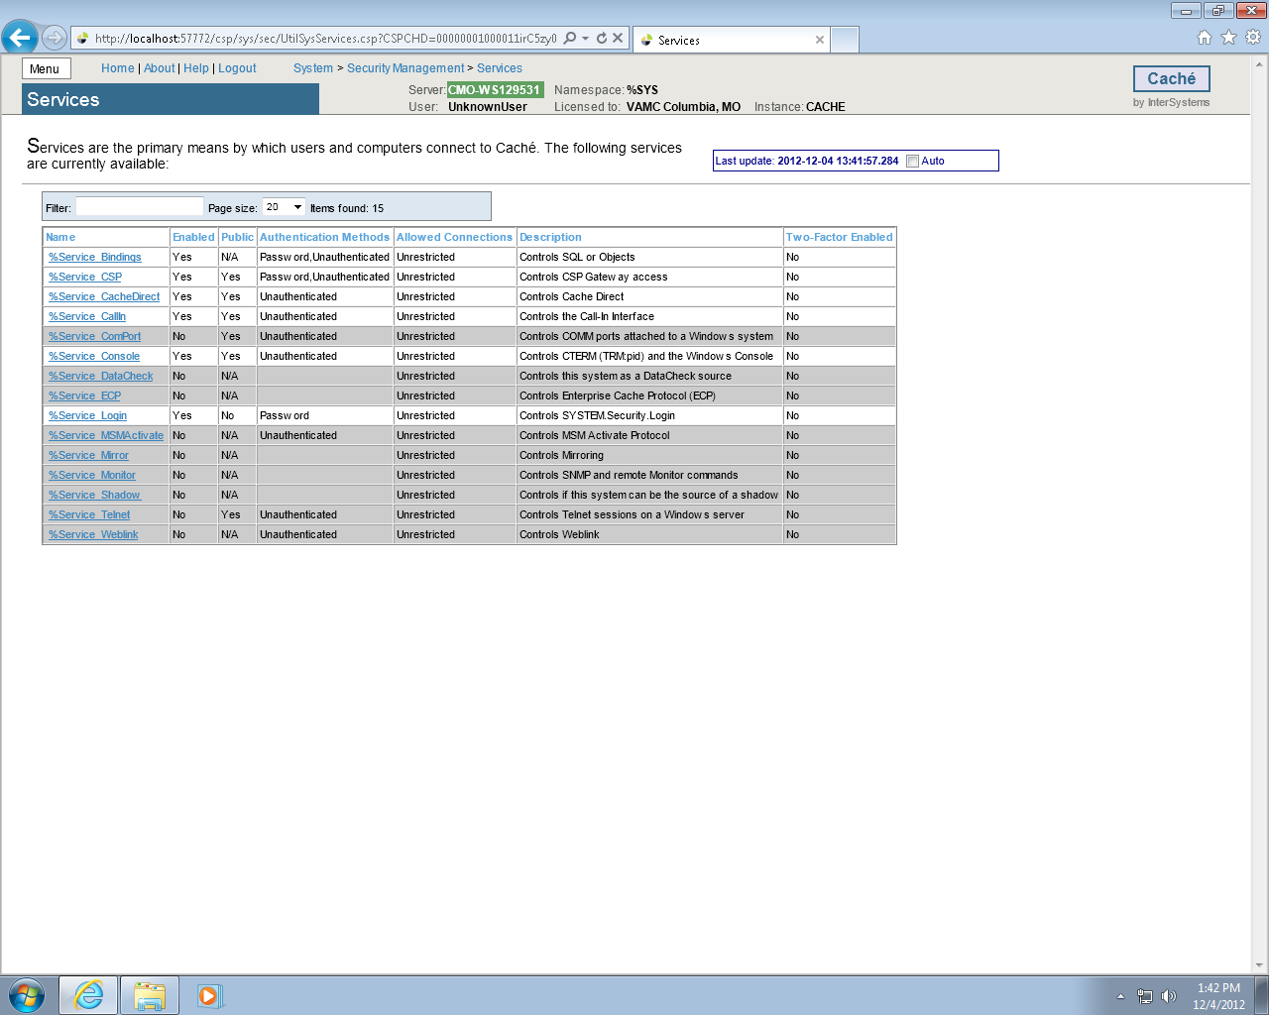

Figure 45

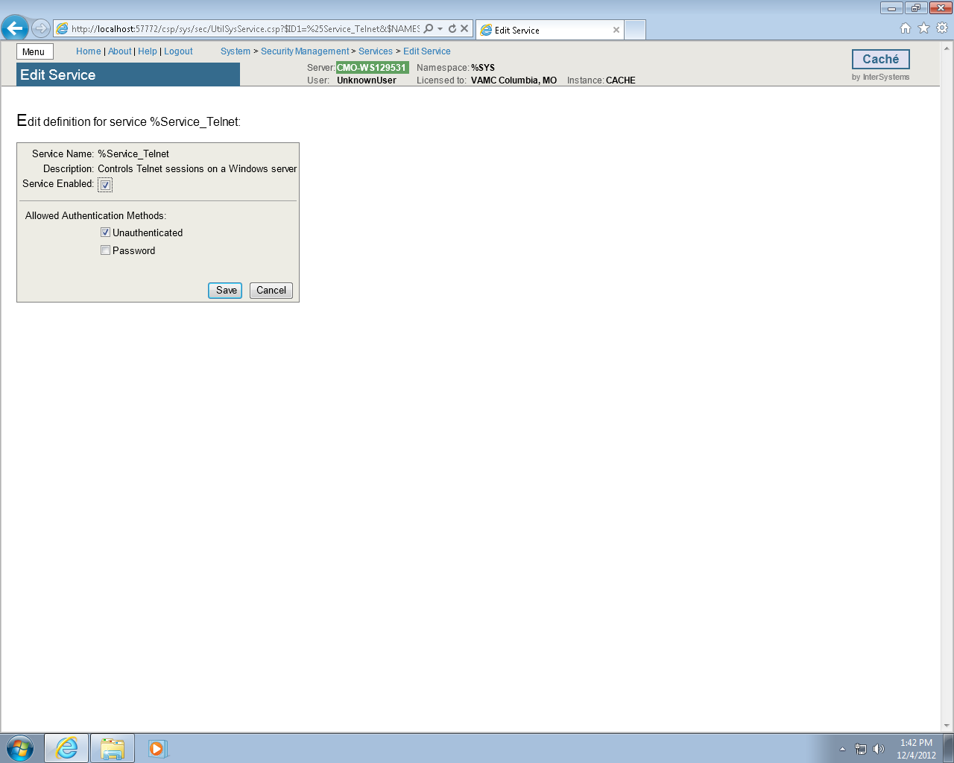

Figure 46

Return to **Home**, select **System Administration** ,then **Configuration** then **Device Settings**, then **Telnet Settings** then **GO** under *View or edit telnet definitions*. Set Telnet **Port** to **19210.** Default setting is 23. (Figures 47-48)

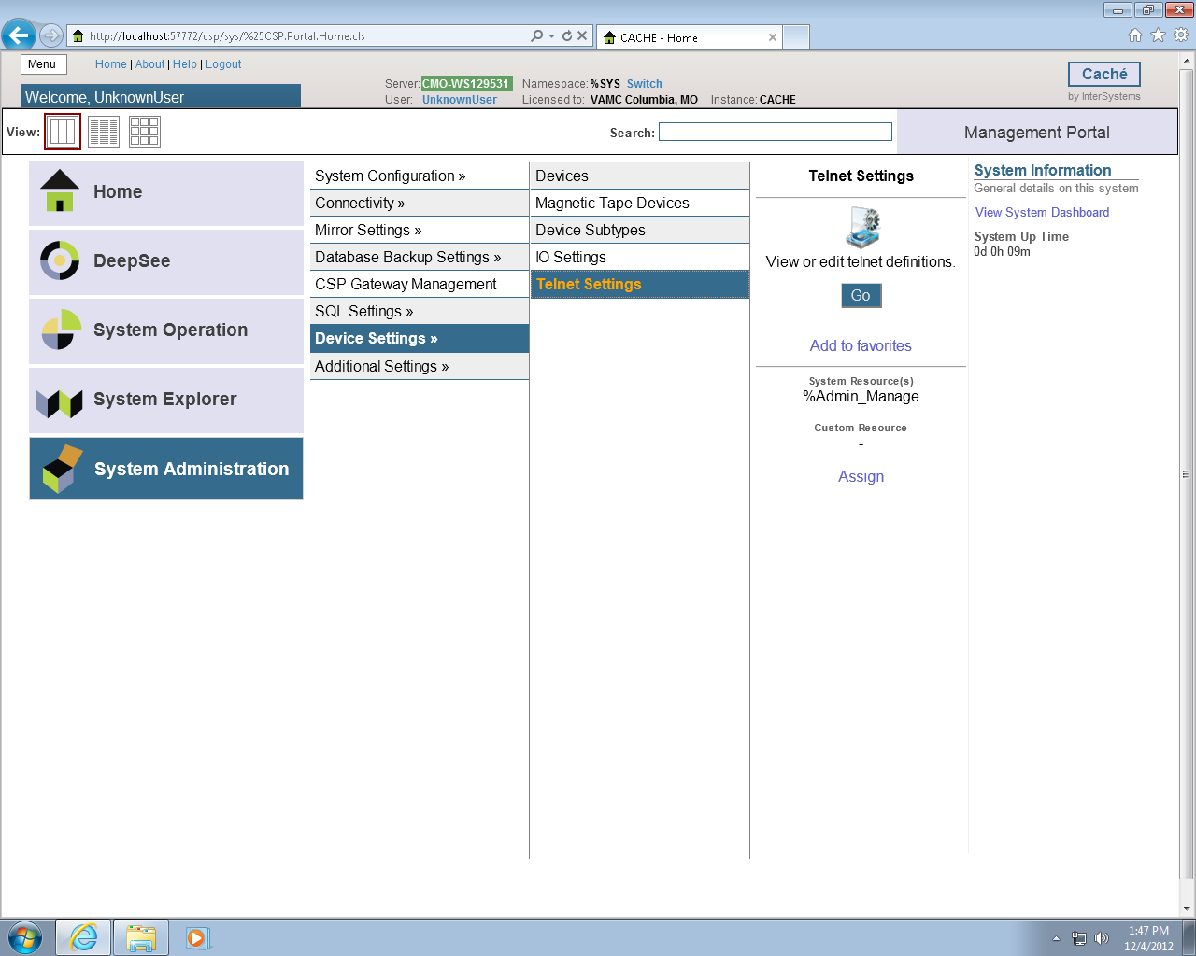

Figure 47

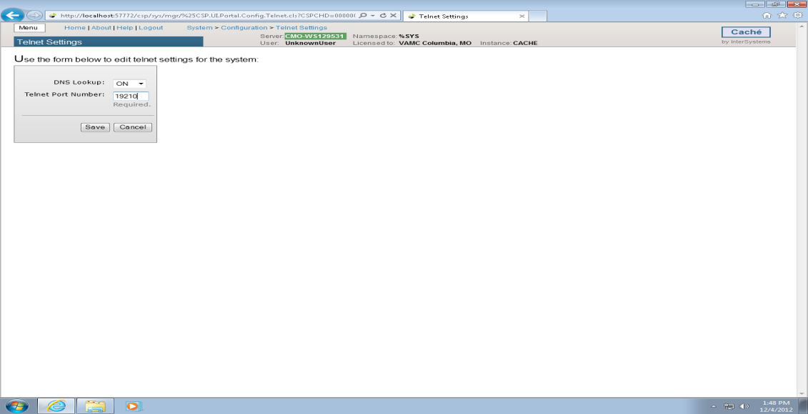

Figure 48

Click **Home**, then **Menu** then **Configure Memory**.

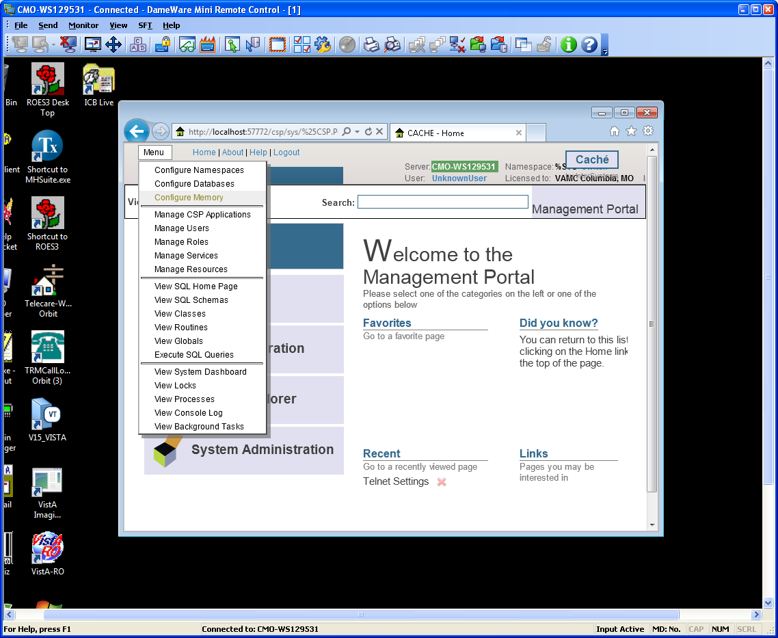

Figure 49

Make sure the “*Start Cache on System Boot*” is checked. If not, check it and click **Save**. Close this window.

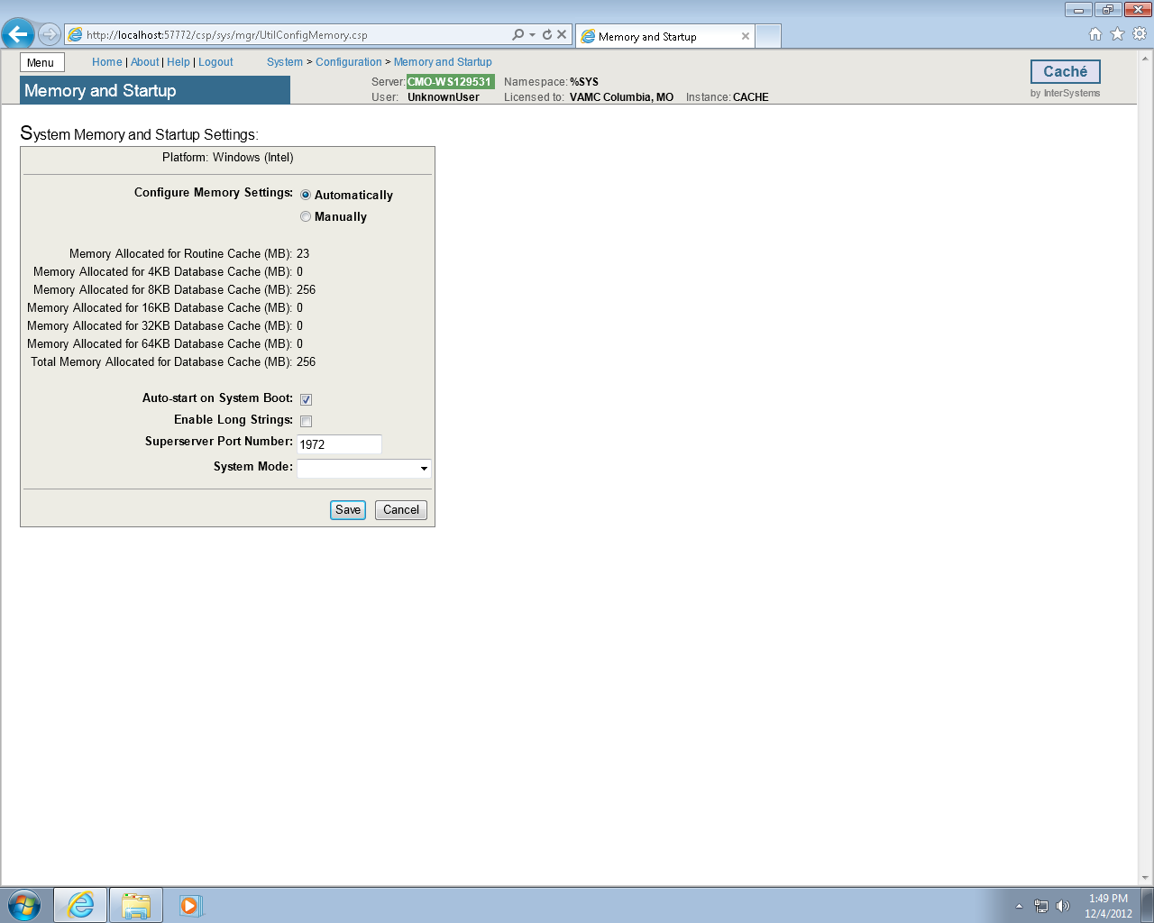

Figure 50

## Setting up the BCMA Shortcut

To create the shortcut from scratch, right click anywhere on the desktop and select **New/Shortcut**.

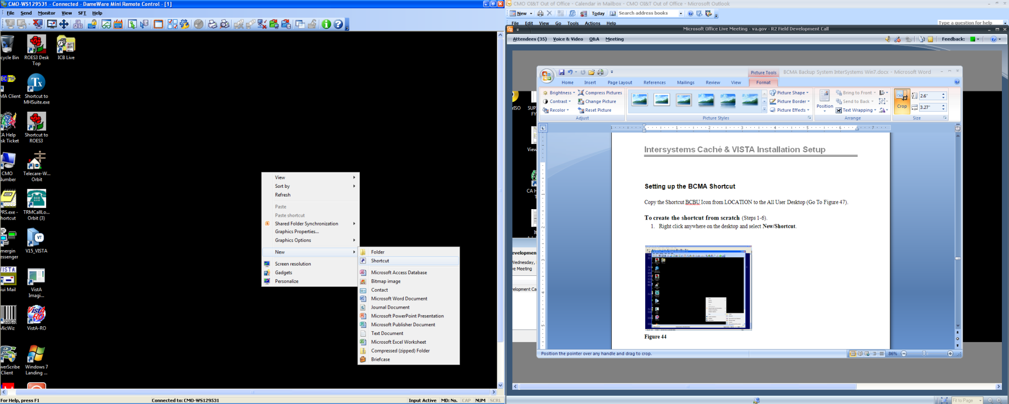

Figure 51

Enter **C:\InterSystems\Cache\bin\css.exe CTERMINAL CACHE** in the *Type the location of the item box.* Click **Next**.

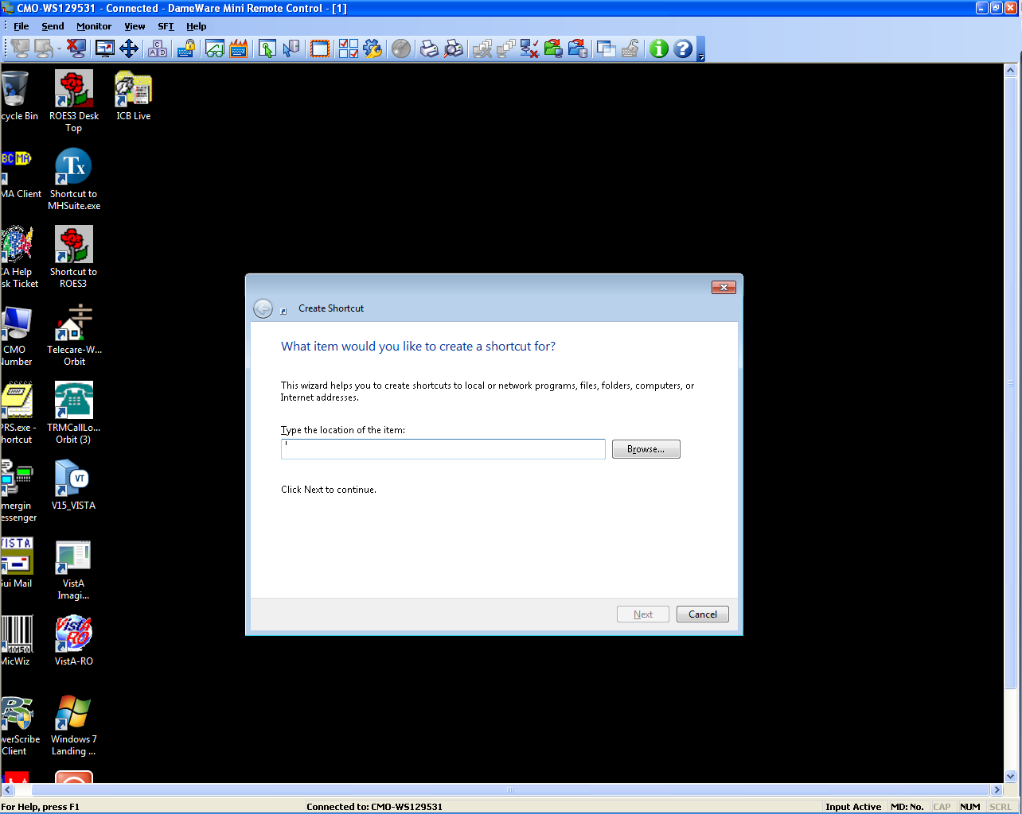

Figure 52

Enter BCBU in the *Type a name for this shortcut* and click Finish (Figure 53).

Copy the Shortcut BCBU Icon to the All User Desktop.

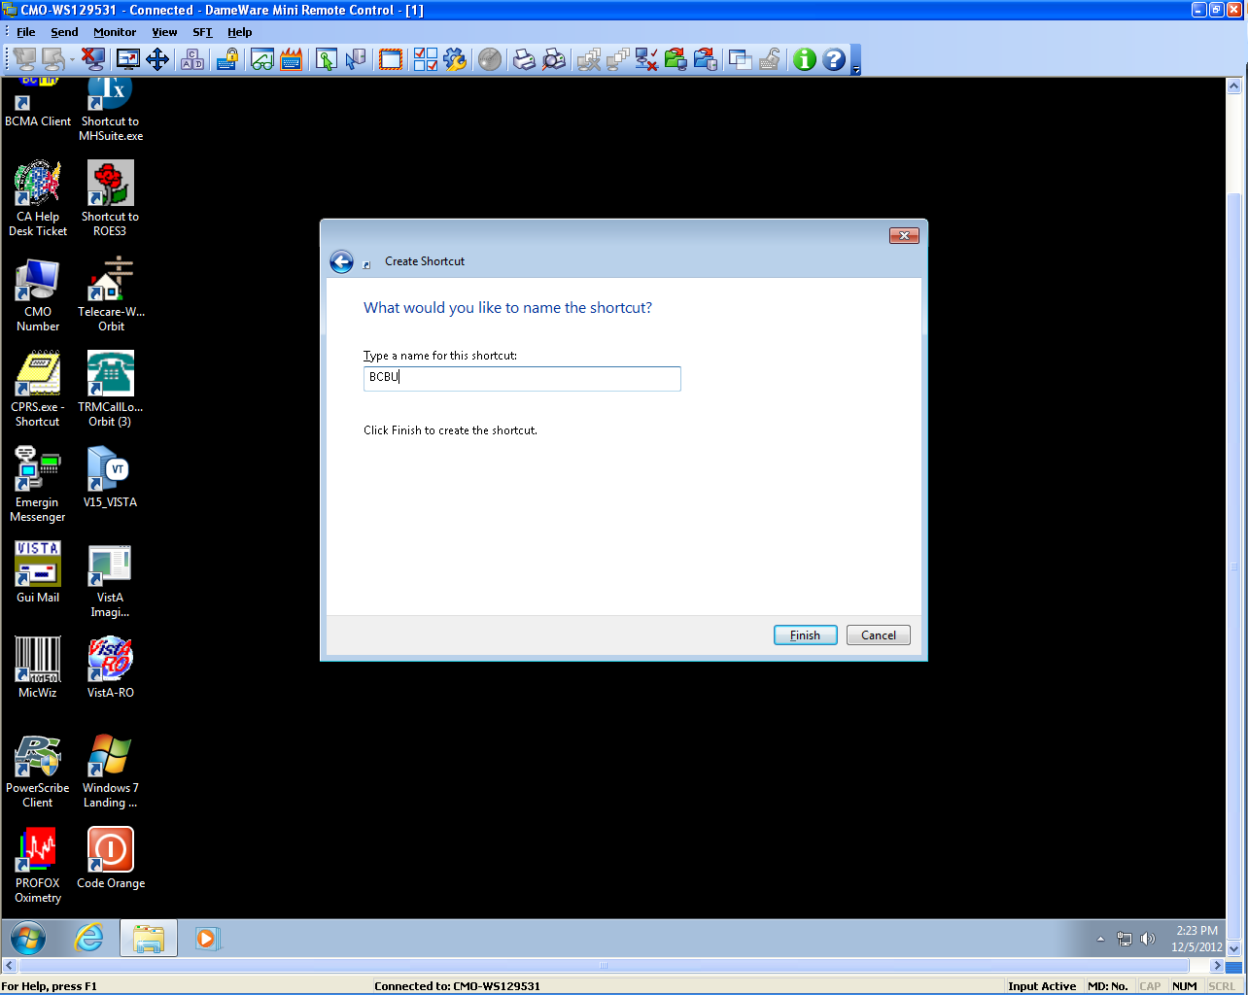

Figure 53

Double-click the BCBU shortcut icon to enter the Backup system on the PC Workstation. Use the appropriate access and verify code to access the system.

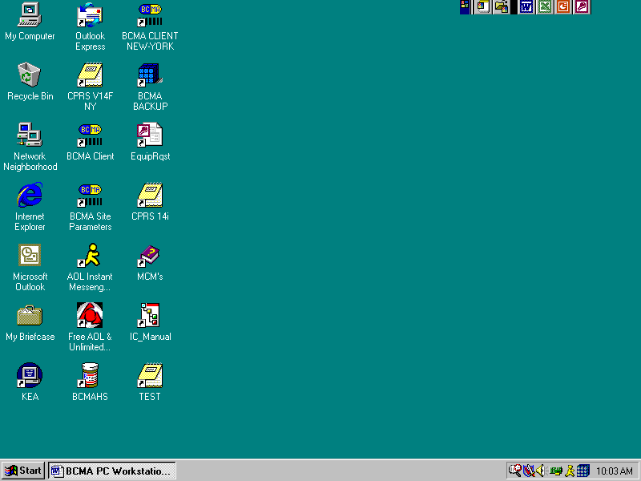

Figure 54

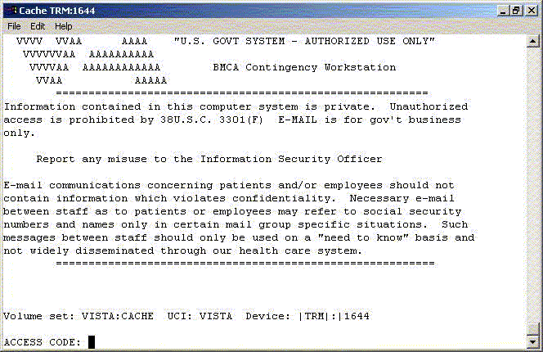

Figure 55

This completes the setup of InterSystems Caché on the BCBU contingency workstation. Refer to the BCBU VistA Install Guide to complete the package setup.

How to Setup the Printer in BCBU PC.

Hook up the printer to the PC.

Install the Window printer drivers.

Click BCBU icon on PC and log in as user that has programmer privileges.

Select Systems Manager Menu Option: *Device Management*

Select Device Management Option: *Device Edit*

Select Device Edit Option: *TRM, TRM, or VTRM Device Edit*

Select Terminal/Printer Device: BCBU

### Edit a TRM or VTRM device

NAME: BCBU PRINTER LOCATION: BCBU WORKSTATION

$I: |PRN| Name of the window’s printer

Example: Window's printer is Lexmark T650 PS3, then enter |PRN| Lexmark T650 PS3

Alt $I:

TYPE: TERMINAL

SUBTYPE: P-HP-P16

SIGN-ON/SYSTEM DEVICE: NO

VOLUME SET(CPU):

ASK DEVICE: NO MARGIN WIDTH:

ASK PARAMETERS: NO PAGE LENGTH:

QUEUING: FORCED SUPPRESS FORM FEED:

Save and Exit.